**IOT BASED SMART IRRIGATION MONITORING SYSTEM**

*A Project Report Submitted in the partial fulfillment of the requirements for the award of the degree of*

## BACHELOR OF TECHNOLOGY IN

**COMPUTER SCIENCE AND ENGINEERING (INTERNET OF THINGS)**

***Submitted by***

## SRI HARSHA DIGVIJAY MULLAPUDI LAGUDU MAYURI (20981A4949) (20981A4929)

**RAJANA PRAKASH MAJJI CHANDRA MOULI (21985A4907) (20981A4932)**

***Under the esteemed guidance of***

## MR. R. RAAKESH KUMAR

**Assistant Professor**

## DEPARTMENT OF COMPUTER SCIENCE AND ENGINEERING(IOT)



**RAGHU ENGINEERING COLLEGE (Autonomous)**

**(Affiliated to JNTU GURUJADA,VIZIANAGARAM, Approved by AICTE, Accredited by NBA, Accredited by NAAC with A+ grade)** [**www.raghuenggcollege.com**](http://www.raghuenggcollege.com/)

## 2023-2024

**RAGHU ENGINEERING COLLEGE**

# (Autonomous)

**(Affiliated to JNTU GURUJADA,VIZIANAGARAM, Approved by AICTE, Accredited by NBA, Accredited by NAAC with A+ grade)**

**Dakamarri, Bhimili Mandal,Visakhapatnam-531162**

[**www.raghuenggcollege.com**](http://www.raghuenggcollege.com/)



**DEPARTMENT OF COMPUTER SCIENCE AND ENGINEERING(IOT)**

**CERTIFICATE**

This is to certify that this project entitled **“ IOT BASED SMART IRRIGATION MONITORING SYSTEM”** done by **“ SRI HARSHA DIGVIJAY MULLAPUDI (20981A4949), LAGUDU MAYURI(20981A4929), RAJANA PRAKASH (21985A4907),**

**MAJJI CHANDRA MOULI (20981A4932)”** are students of B.Tech in the Department of Computer Science and Engineering(IOT), Raghu Engineering College, during the period 2020

-2024, in partial fulfillment for the award of the Degree of Bachelor of Technology in Computer Science and Engineering to the Jawaharlal Nehru Technological University, Kakinada is a record of bonafide work carried out under my guidance and supervision.

**Project Guide Head of the Department**

**Mr. R. RAAKESH KUMAR Dr. OM. PRAKASH,**

Department of CSE. Department of CSE.

Raghu Engineering College, Raghu Engineering College,

Dakamarri (V) Dakamarri (V)

Visakhapatnam. Visakhapatnam.

# DISSERTATION APPROVAL SHEET

***This is to certify that the dissertation titled***

# IOT BASED SMART IRRIGATION MONITORING SYSTEM

***By***

**SRI HARSHA DIGVIJAY MULLAPUDI LAGUDU MAYURI (20981A4949) (20981A4929)**

**RAJANA PRAKSASH MAJJI CHANDR MOULI**

**(21985A4907) (20981A4932)**

***Is approved for the degree of Bachelors of Technology***

**MR. R. RAAKESH KUMAR (Project Guide)**

**ASSISTANT PROFESSOR**

## Internal Examiner

**External Examiner**

## HOD

**Date:**

# DECLARATION

This is to certify that this project titled **“IOT BASED SMART IRRIGATION MONITORING SYSTEM”** is bonafide work done by my team, in partial fulfillment of the requirements for the award of the degree Bachelors of Technology and submitted to the Department of Computer Science and Engineering(IOT), Raghu Engineering College (A), Dakamarri, Visakhapatnam.

We also declare that this project is a result of my own effort and that has not been copied from anyone and I have taken only citations from the sources which are mentioned in the references.

This work was not submitted earlier at any other University or Institute for the award of any degree.

**Place:**

**Date:**

**SRI HARSHA DIGVIJAY MULLAPUDI (20981A4949) LAGUDUMAYURI(20981A4929)**

**RAJANA PRAKASH (21985A4907) MAJJI CHANDRA MOULI (20981A4932)**

## ACKNOWLEDGEMENT

We express our sincere gratitude to my esteemed Institute “Raghu Engineering College”, which has provided us an opportunity to fulfil the most cherished desire to reach my goal.

We take this opportunity with great pleasure to put on record our ineffable personal indebtedness to **Sri Raghu Kalidindi, Chairman of Raghu engineering College** for providing necessary departmental facilities.

We would like to thank the Principal **Dr. Ch. Srinivasu,** Vice-Principal **Dr. A. Vijay Kumar, Dr. E. V. V. Ramana Murthy** Controller of Examination and Management of **“Raghu Engineering College”,** for providing the requisite facilities to carry our project in campus.

Our sincere thanks to **Sri Dr. S. Om Prakash, Head of Department,** Department of Computer Science and Engineering, Raghu Engineering College, for this kind support in the successful completion of this work.

We sincerely express our deep sense of gratitude to **Mr. R. RAAKESH KUMAR, Assistant Professor,** Department of Computer Science and Engineering, Raghu Engineering College, for his perspicacity, wisdom and sagacity coupled with compassion and patience. It is our great pleasure to submit this work under his wing.

We extend our deep hearted thanks to all faculty members of Computer Science Department for their value based imparting of theory and practical subjects, which were used in the project.

We are thankful to the non-teaching staff of the Department of Computer Science and Engineering, Raghu Engineering College, for their inexpressible support.

**Regards:**

**SRI HARSHA DIGVIJAY MULLAPUDI (20981A4949) LAGUDU MAYURI (20981A4929)**

**RAJANA PRAKASH (21985A4907) MAJJI CHANDRA MOULI (20981A4932)**

# ABSTRACT

The internet of things (IOT) describes the network of physical objects things that are embedded with sensors, software, and other technologies for the purpose of connecting data with other devices and systems over internet. Agriculture is the one of the most dominant sectors that nothing can match its importance and the work of it. We here implemented our thoughts and worked on Modern Agriculture technology which is IOT based agriculture monitoring system. Compared to the previous results, here LDR module along with fuzzy logic are used as it helps inusing the parameter of light, In this project the intelligence of the proposed system is based on a smart algorithm, which considers sensed data along with the parameters like air, temperature, humidity, moisture. The complete system where the sensor node data is wirelessly collected over the cloud using web-services and a web-based information visualization and decision support system provides the real-time information insights based on the analysis of sensors data and weather forecast data, if the sensed value goes beyond the threshold values set in the program, the water pump will be automatically switched on/off .We will provide basic Software Prototype and Hardware Model for data visualization.Conventional farming is labor-consuming and the need to continuously monitor crops can be a burden for farmers. By realizing the concept of smart farming based on Internet of Things (IoT) technology, farmers can use a mobile application to observe and monitor air humidity, air temperature, and soil moisture – factors that can affect plant growth. Furthermore, the use of timers to control the pumps in conventional watering systems is not always practical in real-life cases. This paper proposes a framework that enables advanced fuzzy logic to control a pump’s switching time according to user-defined variables, whereby sensors are the main aspect of and contributor to the system. Our proposed idea offers great potential for excellent performance as an interface between the sensors as the input and the IoT as the output medium. A comparison is made between the proposed system andmanual handling. The results prove that the water consumption and watering time has been reduced significantly.

**Keywords:** Agriculture, Fuzzy Logic, Prototype, Smart Farming, Visualization

**TABLE OF CONTENTS**

|  |  |
| --- | --- |
| **CONTENT** | **PAGE NUMBER** |
| Certificate |  |
| Dissertation |  |
| Declaration |  |
| Acknowledgement |  |
| Abstract |  |
| Contents |  |
| List of figures |  |
| **CHAPTER 1:** |  |
| 1.1 Introduction to IOT | 11 |
| 1.2 Why IOT | 13 |
| 1.3 History of IOT | 14 |
| 1.4 Various Names And Features of IOT | 14 |
| 1.5 Structure of IOT | 15 |
| 1.6 IOT Technologies | 15 |
| 1.6.1 RFID | 15-16 |
| **CHAPTER 2:** |  |
| 2.1 Research Contribution | 17 |
| **CHAPTER 3:**  3.1 IOT in agriculture | 27 |
| 3.1.1 Introduction On Agriculture | 28 |
| 3.2 Applications of Agriculture Using IOT | 29 |
| 3.2.1 Robotics | 29 |
| 3.2.2 Drones | 30 |
| 3.2.3 Remote Sensors | 31 |
| 3.2.4 Crop Monitoring | 31 |
| 3.2.5 Weather conditions | 31 |

* + 1. Soil quality 31
    2. Computer Imagining 32
    3. Benefits of Adopting New Technology 33
       1. Climate Conditions 34
       2. Precision Farming 34
       3. Smart Green House 35
       4. Data Analytics 35
       5. Agriculture drones 36
       6. Sensors and Smart Phones 36

CHAPTER 4: 37

* 1. Block Diagram of IOT Base Smart Agriculture Monitoring System 38
  2. Hardware Components 39
     1. Rain Drop Sensor 39-40
     2. Gas(MQ9) Gas Sensor 41-42
     3. Node MCU 43-44
     4. Soil Moisture Sensor 46-49
     5. Temperature Humidity Sensor 50-51
     6. LDR Module 45
     7. Relay Module 52-53
     8. Water Pump 54

CHAPTER 5: 55

* 1. Hard Ware Model of IOT Based Smart Agriculture Monitoring System 56
  2. Aurdino ID Algorithm (Code dumped in Aurdino) 57-62
  3. Hard Ware Model Representation of IOT Based Smart Agriculture Monitoring System

63-65

CHAPTER 6: 66

* 1. Software Used for IOT Based Smart Agriculture System 66
     1. Blink Application Interface 67-68
     2. Dashboard Interface 69

CHAPTER 7: 70

Conclusion Future Scope

References

CHAPTER 8: 75

PAPER PUBLICATION 76

CERTIFICATE 82

**LIST OF FIGURES**

|  |  |
| --- | --- |
| **FIGURE** | **PAGE NUMBER** |
| Fig 1.1 Internet Of things | 12 |
| Fig 1.2 Structure of IOT | 15 |
| Fig 1.3 RFID | 16 |
| Fig 1.4 WIFI | 16 |
| Fig 3.2.2 Drones | 30 |
| Fig 3.2.6 Soil Quality | 32 |
| Fig 3.2.7 Computer Image Through Drones | 32 |
| Fig 4.1 Block Diagram of IOT Base Smart Agriculture Monitoring System | 38 |
| Fig 4.2.1 Rain Drop Sensor | 40 |
| Fig 4.2.2 Gas(MQ9) Gas Sensor | 42 |
| Fig 4.2.3 Node MCU | 43-44 |
| Fig 4.2.4 Soil Moisture Sensor | 46 |
| Fig 4.2.5 Temperature Humidity Sensor | 51 |

|  |  |  |
| --- | --- | --- |
| Fig 4.2.6 | LDR Module | 45 |
| Fig 4.2.7 | Relay Module | 53 |
| Fig 4.2.8 | Water Pump | 54 |
| Fig 5.1 | Hard Ware Model of IOT Based Smart Agriculture System | 57 |
| Fig 6.1.1 | Blink Application Interface | 67 |
| Fig 6.1.2 | Dashboard Interface | 69 |

# CHAPTER 1:

* 1. **INTRODUCTION ON IOT**

The Internet of Things, or IoT, refers to the billions of physical devices around the world that are now connected to the internet, all collecting and sharing data. Thanks to the arrival ofsuper-cheap computer chips and the ubiquity of wireless networks, it's possible to turnanything, from something as small as [a pill](https://www.zdnet.com/article/how-sensors-enabled-eli-lilly-to-improve-the-patient-experience/) to something as big as aeroplane, into a part of the IoT. Connecting these different objects and adding sensors to them adds a level of digital intelligence to devices that would be otherwise dumb, enabling them to communicate real- time data without involving a human being. The Internet of Things is making the fabric ofthe world around us more smarter and more responsive, merging the digital and physical universes.The Internet of Things (IoT) is the network of physical objects or "things" embeddedwith electronics, software, sensors, and network connectivity, which enables these objects to collect and exchange data.

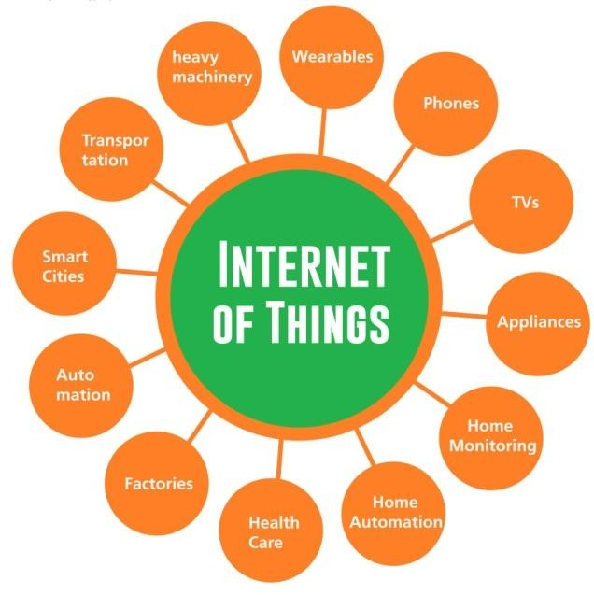

**1.1.Internet of things**

* 1. **Why IOT:**

Internet of Things can connect devices embedded in various systems to the internet. When devices/objects can represent themselves digitally, they can be controlled from anywhere. The connectivity then helps us capture more data from more places, ensuring more ways of increasing efficiency and improving safety and IoT security. IoT is a transformational force that can help companies improve performance through IoT analytics and IoT Security to deliver better results. Businesses in the utilities, oil & gas, insurance, manufacturing, transportation, infrastructure and retail sectors can reap the benefits of IoT by making more informed decisions, aided by the torrent of interactional and transactional data at their disposal .IOT has many applications in agriculture, smart Cities , smart home, healthcare, business sectors, Traffic monitoring, Transport and logistics etc. This is a growing mega trend that will influence everythingfrom businesses to our daily personal lives. Here we are mainly focussing on agriculture as it plays avital role in development of our country’s.

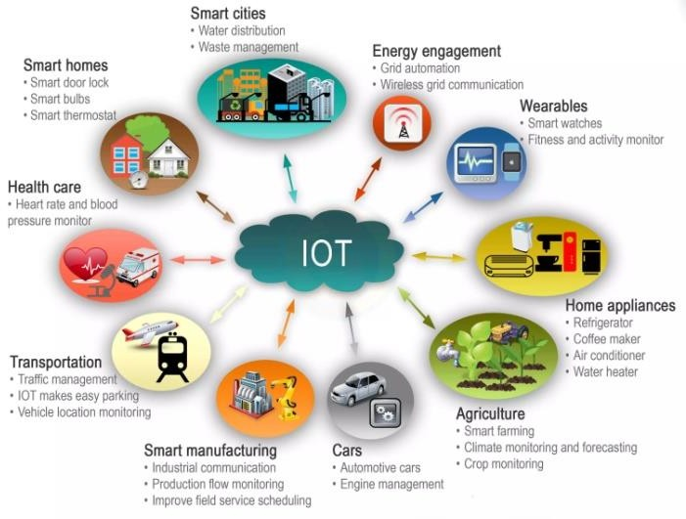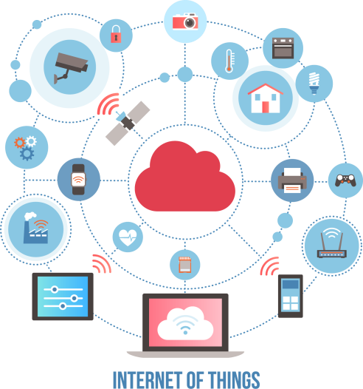

## History of IOT:

* + 1. The concept of a network of smart devices was introduced in 1982, with modified cokemachine that becomes the first internet connected appliance.
    2. Between 1982 to 1999 many companies are working on IOT. But in 1999 IOT is introduced by British technology pioneer Kevin Ashton coined the term in his work atProcter and gamble. But the term IOT did not step up till 2011 later in 2014 it reachedmass market.
    3. IOT allow the objects that will connect through the internet with RFID (Radio Frequency Identification) communication method that include wireless technology and sensors which can identify themselves uniquely**.**

## Various Names & its Features of IoT:

### Various names of IoT:

* 1. M2M (machine to machine)
  2. Internet of everything
  3. World wide web

## Features of IoT:

* 1. Univocally identifiable and addressable objects
  2. It is An Artificial intelligence
  3. Connectivity
  4. It is used as a Sensor
  5. Size considerations (Small devices)

## Structure of IOT:

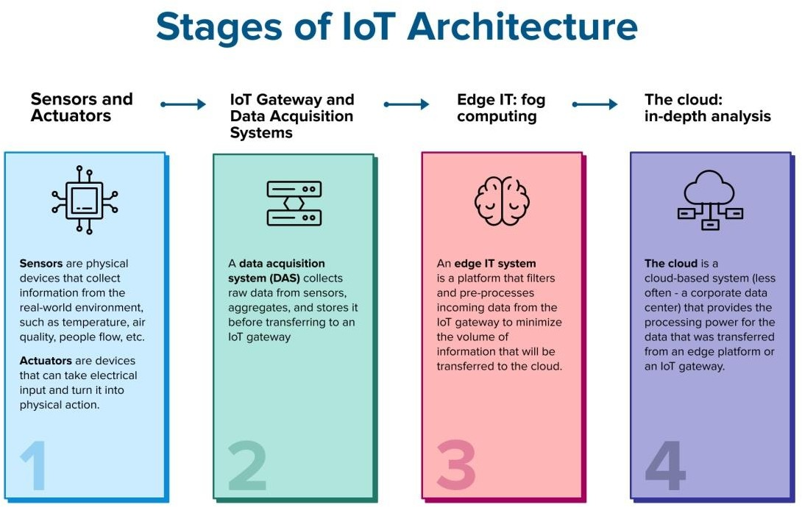

**1.2 Structure of IOT**

IoT system architecture is often described as a **four-stage process** in which data flows from sensors attached to “things” through a network and eventually on to a corporate data center or thecloud for processing, analysis and storage. In the Internet of Things, a “thing” could be a machine, a building or even a person.In the Internet of Things, a “thing” could be a machine, a building or even a person. Processes in the IoT architecture also send data in the other direction in the form of instructions or commands that tell an actuator or other physically connected device to take some action to control a physical process. An actuator could do something as simple as turning on a light or as consequential as shutting down an assembly line if impending failure is detect.

## IOT Technologies:

### RFID:

* + - 1. Widely used in Transport and Logistics.
         1. We can easy to deploy the RFID tags and RFID readers.
         2. The communication range and frequency depend on the type ofTechnology.

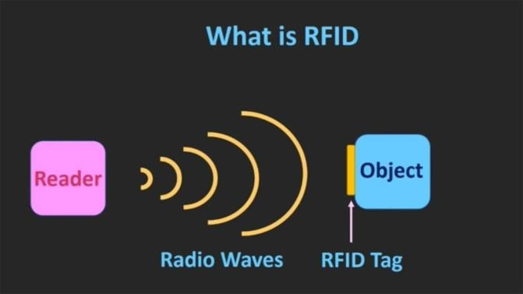

* 1. **RFID**

## WIFI:

1. It is Very common.
2. It is Widely used both in indoor and outdoor environments.
3. Wifi is very low cost
4. Highly interoperable

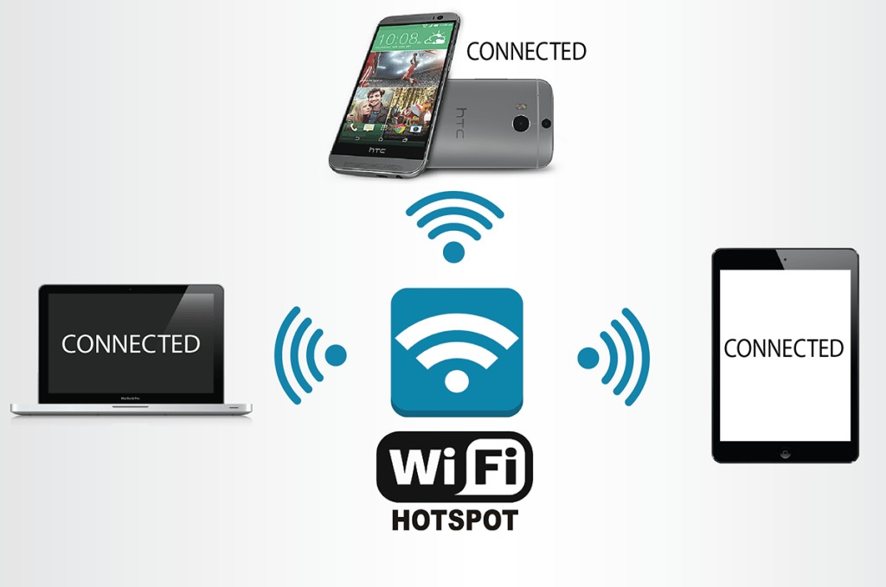

* 1. **WIFI**

# CHAPTER 2

**2.1 RESEARCH CONTRIBUTION**

In this study, we developed a new farming monitoring system that has a robust design, high accessibility, and wireless communication. The system was integrated by using the input from sensors, interpreting by fuzzy logic architecture, and using IoT as the interface with the end-user. Since our aim is to help the farmers, we tried to design the system to be moreunderstandable to them without the need for complex theoretical background. We fully utilized the knowledge from fuzzy systems to provide input for the flow rate identification. Thus, the effectiveness of the process is improved compared to the traditional and manual appliances from the farmers.

The major contribution of our research can be summarized as follows:

A new finding on the effect of the flow rate, which is important for the farmers. The information from the finding will be the guidance for adjusting the specific flow rate, volume, and speed. The effect of flow rate will also be considered for the setting time in each process at the farm, for example, setting time for watering the plant. Thus, the monitoring can be more efficient. We have identified the relationship between the air temperature, air humidity, and soil moisture, and watering time. The information has been transformed into the IoT using the selected platform. The IoT tools were better modified than in the previous literature in terms of visibility and accessibility for the end-user. We also presented the windows of IoT application so that the readers can have a better understanding. **[1]** Conventional farming is labor-consuming and the need to continuously monitor crops can be a burden for farmers. By realizing the concept of smart farming based on Internet of Things (IoT) technology, farmers can use a mobileapplication to observe and monitor air humidity, air temperature, and soil moisture – factors that can affect plant growth. Furthermore, the use of timers to control the pumps in conventional watering systems is not always practical in real-life cases. This paper proposes a framework that enables advanced fuzzy logic to control a pump’s switching time according to user-defined variables, whereby

sensors are the main aspect of and contributor to the system. Our proposed

idea offers great potential for excellent performance as an interface between the sensors as the input and the IoT as the output medium. A comparison is made between the proposed system and manual handling. The results prove that the water consumption and watering time has been reduced significantly.

**[**The agriculture sector faces many challenges such as crop diseases, pest infestation,water shortage, weeds and many more**[2]**. These problems lead to substantial crop loss, economic loss and also causes severe environmental hazards due to the current agriculture practices. The AI and Robotics technologies have the potential to solve these problems efficiently. As the agriculture is a dynamic sector, the problems in agriculture are not generalized by AI and robotics, and a specific solution is provided to a particular complex problem. A variety of systems have been developed to help these challenges and provide a better approach worldwide**.**

Conventional farming is labor-consuming and the need to continuously monitor crops can be a burden for farmers**[3]**. By realizing the concept of smart farming based on Internet ofThings (IoT) technology, farmers can use a mobile application to observe and monitor air humidity, air temperature, and soil moisture – factors that can affect plant growth. Furthermore, the use of timers to control the pumps in conventional watering systems is not always practical inreal-life cases. This paper proposes a framework that enables advanced fuzzy logic to control a pump’s switching time according to user-defined variables, whereby sensors are the main aspect of and contributor to the system.

It is applied in agriculture to plan the several activities and missions properly by utilizing limited resources with minor human interference**[4]**. Currently, plant cultivation using new agriculture methods is very popular among the growers. However, the aeroponics is one of the methods of modern agriculture, which is commonly practiced around the world. In the system, plant cultivates under complete control conditions in the growth chamber by providing a small mist of the nutrient solution in replacement of the soil. The nutrient mist is ejected through atomization nozzles on a periodical basis. During the plant cultivation, several steps including temperature, humidity, light intensity, water nutrient solution level, pH and EC value,CO2

concentration, atomization time, and atomization interval time require proper attention for flourishing plant growth.

Some areas in Indonesia often lack clean water even occur drought if the dry season strikes. However, several other regions of Indonesia have pure water abundance despite the dry season**[5]**. Based on this problem, the authors aimed to design a mobile application of a smart water supply chain based on the Internet of Things (IoT) for admin and users. The app was Control Your Water application. The app developed aimed not only to detect water shortage quickly but also to accommodate online water purchasing. By installing sensors in the water reservoirs, the admin could find out the supply of clean water in the tanks. Information had obtained from the sensor will go to Microcontroller, then the Microcontroller will send it to the database via WIFI. The mobile application displayed information based on data in the database.

By realizing the concept of smart farming based on Internet of Things (IoT) technology, farmers can use a mobile application to observe and monitor air humidity, air temperature, and soil moisture– factors that can affect plant growth**[6]** . Furthermore, the use of timers to control the pumps in conventional watering systems is not always practical in real-life cases. This paper proposes a framework that enables advanced fuzzy logic to control a pump’s switching time according to user-defined variables, whereby sensors are the main aspect of and contributor to the system. Our proposed idea offers great potential for excellent performance as an interface between the sensors as the input and the IoT as the output medium. A comparison is made between the proposed system and manual handling.

Currently, the grading is done based on observations and through experience. The developed system starts the grading process by capturing the fruit's image using a regular digital camera or mobile phone camera**[7]** . Then, the image is transmitted to the processing level where feature extraction, classification and grading is done using Blink application. In this paper, the focus is more on agricultural produce Sorting and Grading technique.

Expert system- a branch of Artificial Intelligence is a collection of programs which has the ability to reason, justify and answer the queries in a particular domain as a human expert would do. It can be applied to various fields**[8]** . Expert system in agriculture is gathering momentum and this paper aims at tackling the control and remedial measures for disease

management for the staple food crop of Karnataka – Finger Millets popularly known as Ragi. The introduction section consists of contributions of expert systems in agriculture. The second section explains the process in Integrated Disease Management (IDM).The third section is about knowledge engineering process which consists of knowledge acquisition and knowledge representation. The fourth section is about the application of fuzzy logic in IDM. The fifth section briefs about defuzzification of IDM**.**

While crop models are widely used to assess the change in crop productivity with climate change, their skill in assessing irrigation water demand or the risk of crop failure in large area impact assessments is relatively unknown**[9]**. The objective of this study is to investigate which aspects of modeling crop water use (reference crop evapotranspiration (ET0), soil water extraction, soil evaporation, soil water balance and root growth) contributes most to the variability in estimates of maize crop water use and the risk of crop failure, and demonstrate the resulting uncertainty in a climate change impact study for Europe. The SIMPLACE crop modeling framework was used to couple the LINTUL5 crop model in factorial combinations of 2–3 different approaches for simulating the 5 aspects of crop water use, resulting in 51 modeling approaches. Using experiments in France and New Zeland, analysis of total sensitivity revealed that ET0 explained the most variability in both irrigated maize water use and rainfed grain yield levels, with soil evaporation also imporatant in the French experiment. In the European impact study, net irrigation requirement differed by 36% between the Penman and Hargreaves ET0 methods in the baseline period. Average EU grain yields were similar between models, but differences approached 1–2 tonnes in parts of France and Southern Europe. EU wide esimates of crop failure in the historical period ranged between 5.4 years for Priestley–Taylor to every 7.9 years for the Penman ET0 methods. While the uncertainty in absolute values between models was significant, estimates of relative changes were similar between models, confirming the utility of crop models in assessing climate change impacts. If ET0 estimates in crop models canbe improved, through the use of appropriate methods, uncertainty in irrigation water demand as well as in yield estimates under drought can be reduced**.**

21st century climate change is projected to result in an intensification of the global hydrological cycle, but there is substantial uncertainty in how this will impact freshwater

availability. A relatively overlooked aspect of this uncertainty pertains to how different methods of estimating potential evapotranspiration (PET) respond to changing climate. Here we investigate the global response of six different PET methods to a 2°C rise in global mean temperature**[10]**. All methods suggest an increase in PET associated with a warming climate. However, differences in PET climate change signal of over 100% are found between methods. Analysis of a precipitation/PET aridity index and regional water surplus indicates that for certain regions and GCMs, choice of PET method can actually determine the direction of projections of future water resources. As such, method dependence of the PET climate change signal is an important source of uncertainty in projections of future freshwater availability.

**]**Fuzzy Systems provide a framework for integrating database management systems and fuzzy logic in order to improve the decision-making process**[11**. In this study, fuzzy system was used for achieving the best cropping pattern in Agriculture. It is crucial to Integrate ecological principles with economic principles to determine optimum models. Four main objectives defined: maximization of net income of farmers, minimizing the amount of water used in agriculture, minimizing the use of chemical fertilizers and chemical pesticides. Different scenarios were defined: single-objective scenarios, double-objective scenarios, triple-objective scenarios and quadruple-objective scenarios. Finally, four proposed cropping patterns in agricultural and horticultural sectors are evaluated. The results clearly demonstrated that the current cropping pattern needed to be changed, the proposed cropping patterns has put ecological and economic principles both in a maximum optimized level together which is due to the use of the fuzzy system.

This paper presents a comprehensive literature survey on the applications of artificial intelligence techniques in agriculture**[12]**. The domain of agriculture faces many challenges such as disease and pest infestation, improper soil treatment, inadequate drainage and irrigation, and many more. These leads to severe crop loss along with environmental hazards due to excessive use of chemicals. Several researches have been conducted to address these issues. The field of artificial intelligence with its rigorous learning capabilities have become a key technique for solving different agriculture related problems. Systems are being developed to assist the agricultural experts for better solutions throughout the world. This literature survey covers 100

important contributions where artificial intelligent techniques were employed to encounter the challenges related to agriculture. This paper addresses the application of artificial intelligent techniques in the major subdomain of agriculture so that the readers are able to capture the multidimensional development of agro-intelligent systems during last 34 years, from 1983 to 2017. Keywords— Artificial Intelligence; Agriculture; Literature Survey; Fuzzy logic; Artificial Neural Networks

This paper explains a proposed algorithm for severity estimation of plant leaf diseases by using maize leaf diseased samples**[13]**. In the literature, a number of researchers have addressed the problem of plant leaf disease severity estimation, but a few, such as Sannakki et al., have used fuzzy logic to determine the severity estimations of the plant leaf diseases. The present paper aims to update the current algorithm used in the “Leaf Doctor” application that is used to estimate the severities of the plant leaf diseases by introducing the benefits of fuzzy logic decision making rules. This method will contribute to precision agriculture technology as it introduces an algorithm that may be embedded in smartphone devices and used in applications, such as a “Leaf Doctor” application. The applications designed based on the algorithm proposed in this study will help users who are inexperienced and not plant pathologists understand thelevel of the estimated disease severity. The use of fuzzy logic inference rules along with image segmentation determines the novelty of this approach in comparison with the available methodsin the literature.

Agriculture automation is the main concern and emerging subject for every country. The world population is increasing at a very fast rate and with increase in population the need for food increases briskly**[14]**. Traditional methods used by farmers aren't sufficient enough to serve the increasing demand and so they have to hamper the soil by using harmful pesticides in an intensified manner. This affects the agricultural practice a lot and in the end the land remains barren with no fertility. This paper talks about different automation practices like IOT, Wireless Communications, Machine learning and Artificial Intelligence, Deep learning. There are some areas which are causing the problems to agriculture field like crop diseases, lack of storage management, pesticide control, weed management, lack of irrigation and water management and all this problems can be solved by above mentioned different techniques. Today, there is an

urgent need to decipher the issues like use of harmful pesticides, controlled irrigation, control on pollution and effects of environment in agricultural practice. Automation of farming practices has proved to increase the gain from the soil and also has strengthened the soil fertility. This paper surveys the work of many researchers to get a brief overview about the current implementation of automation in agriculture. The paper also discusses a proposed system which can be implemented in botanical farm for flower and leaf identification and watering using IOT.

In the current era of sustainable development, energy planning has become complex due to the involvement of multiple benchmarks like technical, social, economic and environmental. This in turn puts major constraints for decision makers to optimize energy alternatives independently and discretely especially in case of rural communities**[15]**. In addition, topographical limitations concerning renewable energy systems which are mostly distributed in nature, the energy planning becomes more complicated. In such cases, decision analysis plays a vital role for designing such systems by considering various criteria and objectives even at disintegrated levels of electrification. Multiple criteria decision making (MCDM) is a branch of operational research dealing with finding optimal results in complex scenarios including various indicators, conflicting objectives and criteria. This tool is becoming popular in the field of energy planning due to the flexibility it provides to the decision makers to take decisions while considering all the criteria and objectives simultaneously. This article develops an insight into various MCDM techniques, progress made by considering renewable energy applications over MCDM methods and future prospects in this area. An extensive review in the sphere of sustainable energy has been performed by utilizing MCDM technique.

Since agriculture is the major water consumer, web services have been developed to provide the farmers with considerate irrigation suggestions. This study improves an existing irrigation web service, based on the IRRINET model, by describing a protocol for the field implementation of a fully automated [irrigation system](https://www.sciencedirect.com/topics/earth-and-planetary-sciences/irrigation-system)**[16]**. We demonstrate a Fuzzy [Decision](https://www.sciencedirect.com/topics/computer-science/decision-support-systems) Support System to improve the irrigation, given the information on the crop and site characteristics. It combines a [predictive model](https://www.sciencedirect.com/topics/computer-science/predictive-model) of soil moisture and an inference system computing the most appropriate irrigation action to keep this above a prescribed “safe” level. Three crops were used for testing the system: corn, kiwi, and potato. This Fuzzy Decision

Support System (FDSS) favourably compared with an existing agricultural model and data-base (IRRINET). The sensitivity of the FDSS was tested with random rainfall and also in this extended case the water saving was confirmed

Since agriculture is the major water consumer, web services have been developed to provide the farmers with considerate irrigation suggestions. This study improves an existing irrigation web service, based on the IRRINET model, by describing a protocol for the field implementation of a fully automated [irrigation system](https://www.sciencedirect.com/topics/earth-and-planetary-sciences/irrigation-system). We demonstrate a Fuzzy [Decision](https://www.sciencedirect.com/topics/computer-science/decision-support-systems) Support System to improve the irrigation, given the information on the crop and site characteristics. It combines a [predictive model](https://www.sciencedirect.com/topics/computer-science/predictive-model) of soil moisture and an inference system computing the most appropriate irrigation action to keep this above a prescribed “safe” level. Three crops were used for testing the system: corn, kiwi, and potato. This Fuzzy Decision Support System (FDSS) favourably compared with an existing agricultural model and data-base (IRRINET)**[17]** . The sensitivity of the FDSS was tested with random rainfall and also in this extended case the water saving was confirmed.

In recent years, intelligent sensor techniques have achieved significant attention in agriculture**[18]**. It is applied in agriculture to plan the several activities and missions properly by utilising limited resources with minor human interference. Currently, plant cultivation using new agriculture methods is very popular among the growers. However, the aeroponics is one of the methods of modern agriculture, which is commonly practiced around the world. In the system, plant cultivates under complete control conditions in the growth chamber by providing a small mist of the nutrient solution in replacement of the soil. The nutrient mist is ejected through atomization nozzles on a periodical basis. During the plant cultivation, several steps including temperature, humidity, light intensity, water nutrient solution level, pH and EC value, CO2 concentration, atomization time, and atomization interval time require proper attention for flourishing plant growth. Therefore, the object of this review study was to provide significant knowledge about early fault detection and diagnosis in aeroponics using intelligent techniques (wireless sensors). So, the farmer could monitor several paraments without using laboratory instruments, and the farmer could control the entire system remotely. Moreover, the technique also provides a wide range of information which could be essential for plant researchers and

provides a greater understanding of how the key parameters of aeroponics correlate with plant growth in the system. It offers full control of the system, not by constant manual attention from the operator but to a large extent by wireless sensors. Furthermore, the adoption of the intelligent techniques in the aeroponic system could reduce the concept of the usefulness of the system due to complicated manually monitoring and controlling process.

Predicting the influence of climate variations on crop yield demands an appropriate model. In this study, Fuzzy logic based crop yield estimation is undertaken considering temperature, humidity and moisture of soil as input parameters**[19]**. By subjecting these parameters to fuzzy arithmetic, crisp value of yield is obtained. Trapezoidal membership function is considered in the fuzzy modeling. The results are validated using available open source literature. It has been verified theoretically that air humidity 65%-75%, air temperature 18-290 C and soil moisture 60-80% would give high yield.

Precision breeding techniques have been widely used to optimize expenses and increase livestock yields. Notwithstanding, the joint use of heterogeneous sensors and artificial intelligence techniques for the simultaneous analysis or detection of different problems that cattlemay present has not been addressed**[20]**. This study arises from the necessity to obtain a technological tool that faces this state of the art limitation. As novelty, this work presents a multi-agent architecture based on virtual organizations which allows to deploy a new embedded agent model in computationally limited autonomous sensors, making use of the Platform for Automatic coNstruction of orGanizations of intElligent Agents (PANGEA). To validate the proposed platform, different studies have been performed, where parameters specific to each animal are studied, such as physical activity, temperature, estrus cycle state and the moment in which the animal goes into labor. In addition, a set of applications that allow farmers to remotely monitor the livestock have been developed.

## CHAPTER 3

* 1. **IOT IN AGRICULTURE**

## 3.1.1 INTRODUCTION ON AGRICULTURE

Internet of Things (IoT) device is every object that can be controlled through the internet. IoT devices have become popular in consumer markets with wearable IOT (Internet of Wearable Things) such as smartwatches and home management products like Google home. It is estimated over 30 billion devices could be connected to the Internet of Things by 2020. The applications of IoT in farming target conventional farming operations to meet the increasing demands and decrease production loses. IoT in agriculture uses robots, drones, remote sensors and computer imaging combined with continuously progressing machine learning and analytical tools formonitoring crops, surveying and mapping the fields and provide data to farmers for rational farm management plans to save both time and money.Planting a tree in an environment where the seedor the plant would not get water adequately through natural sources like rain or ground water inits initial phases has been always a matter of concern for tree planters. This is where an autonomous moisture monitor for plants system can help. The system timely monitors the moisture level of the soil. If at the time of monitoring it comes to know that the moisture level of the soil is lower than recommended then it will raise an audio visual alert. This alert is then received by the care taker of the plant. When the care taker waters the plant the alarm goes offand the monitoring cycle continues. As we can see in today’s world only some devices like PC’s and mobiles are connected to internet. Now-a-days world is fully overtaken by the internet

and internet of things. Internet is use for basic need of all human beings. The Internet of Things (IOT) is the network of physical objects. It simply means to monitor a physical device or machine or it is inter-networking of physical devices which is embedded with electronics,sensors, software and network connectivity to enable it to achieve greater value and services by exchanging data with the manufacturer IOT permits objects to be sensed or controlled remotely across the network infrastructure. The result improves accuracy, economic benefits, efficiency and reduces intervention of human. In this Project we are going to deal with basic and important concepts of IOT and its scope in upcoming future. This Practical Studies explains the need of IOT in day to day life for different applications and gives brief information about IOT. IOT contributes significantly toward revolutionary farming methods. So we are trying to demonstrate IOT in Automatic watering system. Automatic watering system monitors and maintain the approximate moisture content in soil. Node MCU is used as microcontroller to implement the control unit. The set up uses the temperature sensor, moisture sensor and humidity sensor which measure the approximate temperature, moisture and humidity in the soil. This value enables the system to use appropriate quantity of water which avoids over/under irrigation.

## Application of IOT in agriculture:

* + 1. **Robotics:**

Since the industrial revolution in the 1800s, automation is only getting advanced to efficiently handle more sophisticated tasks and increase production. With increasing demands and shortage of labor across the globe, agriculture robots or commonly known as robots are starting to gain attention among farmers. Crop production decreased by an estimated 213 crores approximate ($3.1 billion) a year due to labor shortages in the USA alone. Recent advancements in sensors and AI technology that lets machines to train on their surroundings has made robots more notable. We are still in the early stages of an ag robotics revolution with most of the products still in early trial phases and R&D mode. These smart robots use digital image processing to look through the images of weeds in their database to detect similarity with crops and weed out or spray them directly by their robotic arms. With increasing number of plants becoming resistant to pesticides they are a boon to the environment and also to farmers who used to spread the pesticides throughout the farm-an estimated 13000 kgs (3 billion pounds) ofherbicides applied at a cost of 1725 crores ($25B) each year, thus reducing their overall cost.

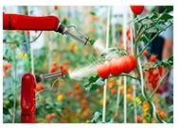

* + 1. **robotics**

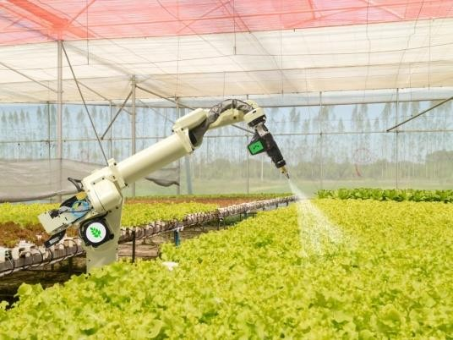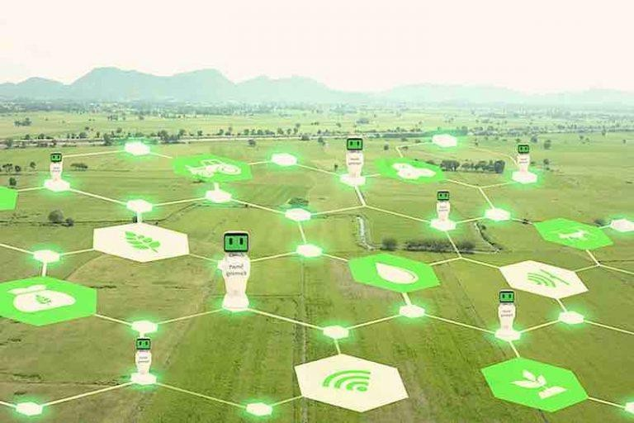

## Drones:

Agriculture is one of the major industries to incorporate drones. Drones equipped with sensors and cameras are used for imaging, map and surveying the farms. There are ground based drones and aerial drones. Ground drones are bots that survey the fields on wheels. Aerial drones- formally known as unmanned aerial vehicles (UAVs) or unmanned aircraft systems (UASs) are flying robots. Drones can be remotely controlled remote or they can fly automatically through software-controlled flight plans in their embedded systems, working in coordination with sensors and GPS. From the drone data, insights can be drawn regarding crop health, irrigation, spraying, planting, soil and field, plant counting and yield prediction and much more. Drones can either be scheduled for farm surveys (drone as a service) or can be bought and stored near farms where they can be recharged and maintained. After the surveys the drones need to be taken to nearby labs to analyze the data that has been collected.

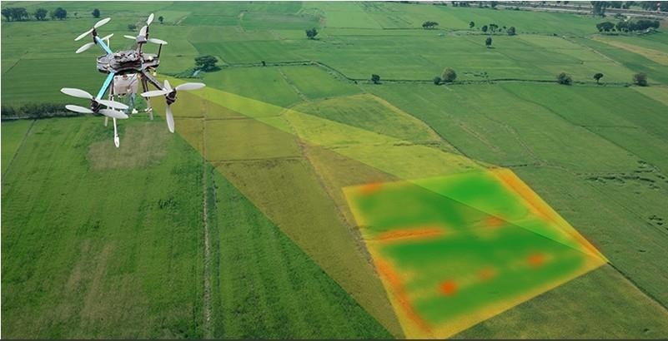

* + 1. **Drones**

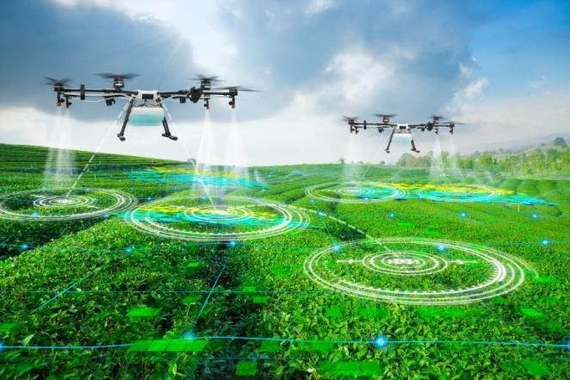 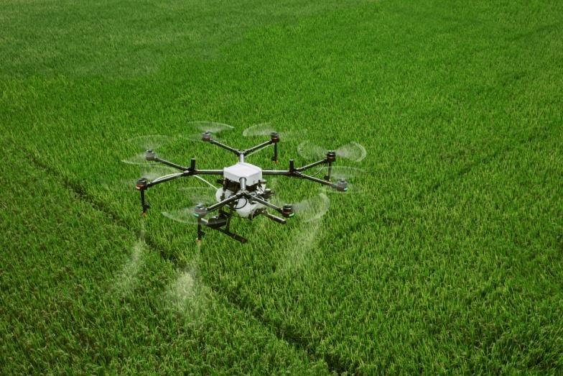

## Remote sensor:

IoT based remote sensing utilizes sensors placed along the farms like weather stations for gathering data which is transmitted to analytical tool for analysis. Sensors are devices sensitiveto anomalies. Farmers can monitor the crops from analytical dashboard and take an action based on insights.

## Crop monitoring:

Sensors placed along the farms monitor the crops for changes in light, humidity, temperature, shape and size. Any anomaly is detected by the sensors is analyzed and farmer is notify .Thus remote sensing can help prevent the spread of diseases and keep an eye on the growth of crops.

## Weather conditions:

The data collected by sensors in terms of humidity, temperature, moisture precipitation and dew detection help in determining the weather pattern in farms so that cultivation is done for suitable crops.

## Soil quality:

The analysis of quality of soil helps in determining the nutrient value and drier areas of farms, soil drainage capacity or acidity, which allows to adjust the amount of water needed for irrigation and the opt most beneficial type of cultivation.

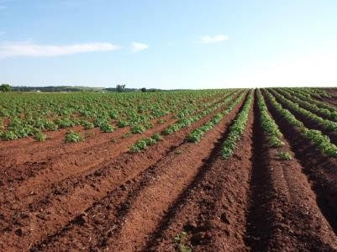 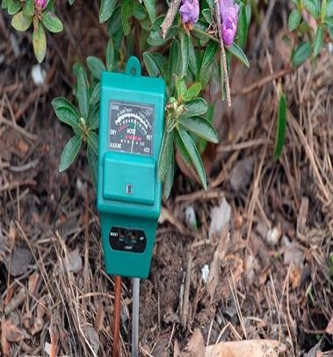 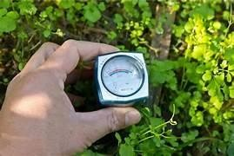

* + 1. **Soil quality**

## Computer imaging:

Computer imaging involves the use of sensor cameras installed at different corners of the farm or drones equipped with cameras to produce images which undergo digital image processing. Digital image processing is the basic concept of processing an input image using computer algorithms. Image processing views the images in different spectral intensities such as infrared, compares the images obtained over a period time and detects anomalies thus analyzing limiting factors and helps better management of farms.

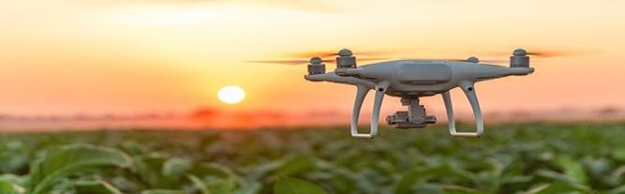

* + 1. **Computer imaging**

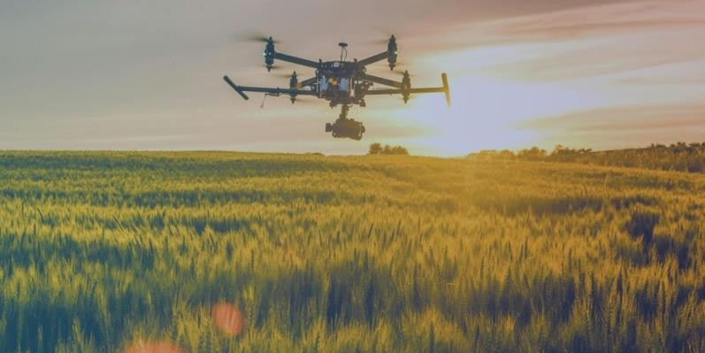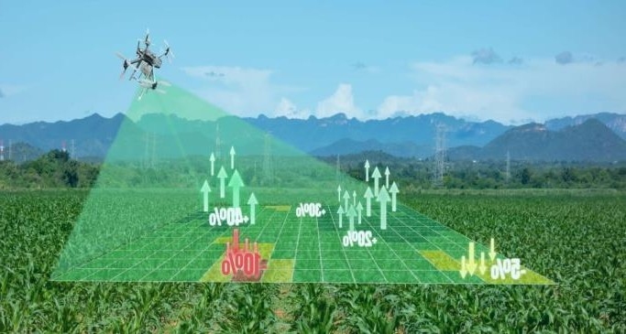

## Benefits of adopting new technology:

Till now the [Industrial Internet of Things (IoT)](https://www.biz4intellia.com/industrial-iot/) has disrupted many industries and the Agriculture Industry isn't an exception. Till the end of 2018, the connected agriculture market stood at USD 1.8 billion globally and the change hasn't stopped yet. It is expected to grow toUSD

4.3 billion by 2023 at a Compound Annual Growth Rate (CAGR) of 19.3%.The IoT technology has realized the smart wearable's, connected devices, automated machines, and driverless cars. However, in agriculture, the IoT has brought the greatest impact.

Recent statistics reveal that the global population is about to reach 9.6 billion by 2050. And to feed this massive population, the agriculture industry is bounded to adopt the Internet of Things. Amongst the challenges like extreme weather conditions, climatic changes, environmental impact, IoT is eradicating these challenges and helping us to meet the demand for more food.

Throughout the world, mechanical innovations such as tractors and harvesters took place and brought into the agriculture operations in the late 20th century. And the agriculture Industry relies heavily on innovative ideas because of the steadily growing demand for food.

The Industrial IoT has been a driving force behind increased agricultural production at a lower cost. In the next several years, the use of smart solutions powered by IoT will increase in the agriculture operations. In fact, few of the recent report tells that the IoT device installation will see a compound annual growth rate of 20% in the agriculture industry. And the no. of connected devices (agricultural) will grow from 13 million in 2014 to 225 million by 2024.

Due to lack of constant and reliable communication network infrastructure, an [IoT solutions](https://www.biz4intellia.com/) provider as well as the business owners had faced implementation challenges in remote or less developed regions .But, many network providers are making it possible by introducing satellite connectivity and expending cellular networks.

## Climate Conditions:

Climate plays a very critical role for farming. And having improper knowledge about climate heavily deteriorates the quantity and quality of the crop production. But IoT solutions enable you to know the real-time weather conditions. Sensors are placed inside and outside of the agriculture fields. They collect data from the environment which is used to choose the right crops which can grow and sustain in the particular climatic conditions. The whole IoT ecosystem is made up of sensors that can detect real-time weather conditions like humidity, rainfall, temperature and more very accurately. There are numerous no. of sensors available to detect all these parameters and configure accordingly to suit your smart farming requirements. These sensors monitor the condition of the crops and the weather surrounding them. If any disturbing weather conditions are found, then an alert is send. What gets eliminated is the need of the physical presence during disturbing climatic conditions which eventually increases the productivity and help farmers to reap more agriculture benefits.

## Precision Farming:

Precision Agriculture/Precision Farming is one of the most famous applications of IoT in Agriculture. It makes the farming practice more precise and controlled by realizing smart farming applications such as livestock monitoring, [vehicle tracking](https://www.biz4intellia.com/gps-fleet-tracking-solution/), field observation, and inventory monitoring. The goal of precision farming is to analyze the data, generated via sensors, to react accordingly. Precision Farming helps farmers to generate data with the help of sensors and analyze that information to take intelligent and quick decisions. There are numerous precision farming techniques like irrigation management, livestock management, vehicle tracking and many more which play a vital role in increasing the efficiency and effectiveness. With the help of Precision farming, you can analyze soil conditions and other related parameters to increase the operational efficiency. Not only this you can also detect the real-time working conditions of the connected devices to detect water and nutrient level.

## Smart Greenhouse:

To make our greenhouses smart, IoT has enabled weather stations to automatically adjust the climate conditions according to a particular set of instructions. Adoption of IoT in Greenhouses has eliminated the human intervention, thus making entire process cost-effective and increasing accuracy at the same time. For example, using solar-powered IoT sensors builds modern and inexpensive greenhouses. These sensors collect and transmit the real-time datawhich helps in monitoring the greenhouse state very precisely in real-time. With the help of the sensors, the water consumption and greenhouse state can be monitored via emails or SMS alerts. Automatic and smart irrigation is carried out with the help of IoT. These sensors help to provide information on the pressure, humidity, temperature and light levels.

## Data Analytics:

The conventional database system does not have enough storage for the data collected from the IoT sensors. Cloud based data storage and an end-to-end IoT Platform plays an important role in the smart agriculture system. These systems are estimated to play an important role such that better activities can be performed. In the IoT world, sensors are the primary source of collecting data on a large scale. The data is analyzed and transformed to meaningful information using analytics tools. The data analytics helps in the analysis of weather conditions, livestock conditions, and crop conditions. The data collected leverages the technological innovations and thus making better decisions. With the help of the IoT devices, you can knowthe real-time status of the crops by capturing the data from sensors. Using predictive analytics, you can get an insight to make better decisions related to harvesting. The trend analysis helps the farmers to know upcoming weather conditions and harvesting of crops. IoT in the Agriculture Industry has helped the farmers to maintain the quality of crops and fertility of the land, thus enhancing the product volume and quality.

## Agricultural Drones:

Technological advancements has almost revolutionized the agricultural operations and the introduction of agricultural drones is the trending disruption. The Ground and Aerial drones are used for assessment of crop health, crop monitoring, planting, crop spraying, and field analysis. With proper strategy and planning based on real-time data, drone technology has given a high rise and makeover to the agriculture industry. Drones with thermal or multispectral sensors identify the areas that require changes in irrigation. Once the crops start growing, sensorsindicate their health and calculate their vegetation index. Eventually smart drones have reduced the environmental impact. The results have been such that there has been a massive reductionand much lower chemical reaching the groundwater.

## Sensors & Smart phones:

* + - 1. Sensors acts as a primary device to collect data from the Environment.
      2. A smart phone is just a mobile phone that has access to the internet.
      3. 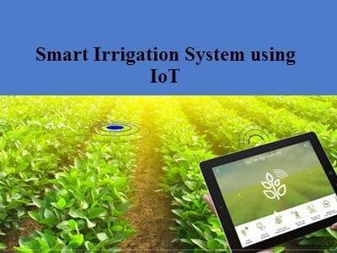The I Phone has a lot of different types of Sensors.

**3.2.14 Sensors & Smart phones:**

# CHAPTER 4

## 4.1 BLOCK DIAGRAM OF IOT BASED SMART IRRIGATION MONITORING SYSTEM

The below block diagram consists of temperature humidity sensor, rain drop sensor, light, gas(MQ9) sensor, node MCU, relay module.so these all sensors are given as inputs to the node MCU. The sensor is interface with Arduino Uno such as DHT11 Temperature, Humidity, Soil moisture and Rain, detection sensor is used. The data acquired from sensors are transmitted to the web server using wireless transmission (WIFI moduleESP8266).The data processing is the task of checking various sensors data received from the field with the already fixed threshold values.

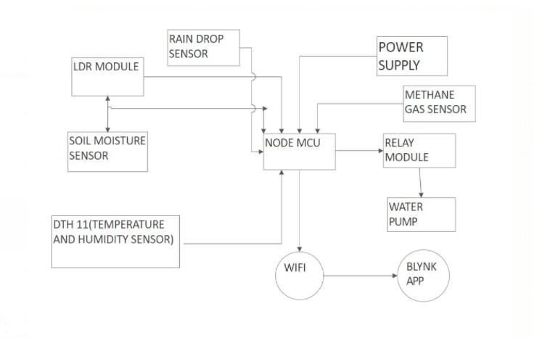

* 1. **BLOCK DIAGRAM OF IOT BASED SMART IRRIGATION MONITORING SYSTEM**

The above diagram represent that temperature humidity sensor,rain drop sensor,light,gas(MQ9) sensor,node mcu, relay module.so these all sensors are given as inputs to the node mcu The detailed proposed method works on below hardware successive components.

## HARDWARE COMPONENTS

* + 1. Rain Drop Sensor
    2. Gas(MQ9) Gas Sensor
    3. Node MCU
    4. Soil Moisture Sensor
    5. Temperature Humidity Sensor
    6. LDR Module
    7. Relay Module
    8. Water Pump

## 4.2.1 Raindrop sensor:

Raindrop sensor is basically a board on which nickel is coated in the form of lines. It works on the principal of resistance. Rain Sensor module allows to measure moisture via analog output pin and it provides a digital output when a threshold of moisture exceeds. The module is based on the LM393 op amp. It includes the electronics module and a printed circuit board that “collects” the raindrops. As raindrops are collected on the circuit board, they create paths of parallel resistance that are measured via the op amp. The sensor is a resistive dipole that shows less resistance when wet and more resistance when dry. Whenthere is no rain drop on board it increases the Resistance so we gets high voltage accordingto V=IR .When rain drop present it reduces the resistance because water is a conductor of electricity and presence of water connects nickel lines in parallel so reduces resistance and reduces voltage drop across it.

## Features:

1. Operating voltage: 5V
2. Provide both digital and analog output
3. Adjustable sensitivity
4. Output LED indicator
5. Compatible with Arduino
6. TTL Compatible
7. Bolt holes for easy installation
8. Jumper wires included

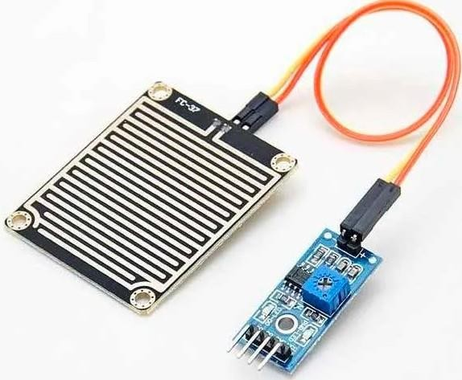

* + 1. **Rain Drop Sensor**

## Gas sensor(MQ9):

A Gas(MQ9) Sensor is a device used as an integral part of a fixed gas detection system for the purposes of monitoring and detecting levels of gas(MQ9) in air in % LEL (Lower Explosive Limit) levels or in percent by volume levels .There are two technologies used to manufacture Gas(MQ9) Sensors, Catalytic Bead and Infrared sensor technologies. Catalytic Bead sensors predate Infrared sensors, and are prone to being poisoned by silicone, lead, sulfur and halogenated compounds. They also require frequent calibration and although less costly than an Infrared sensor, require replacement on a more frequent basis. Because they are lower in cost, some end users still prefer to use Catalytic Bead sensors as a Gas(MQ9) Sensor, especially where there could be other combustible solvent vapors preset that the Catalytic Bead sensor will detect, while an Infrared sensor would not .As a Gas(MQ9) Sensor, Infrared sensor technology has now become the dominant Gas(MQ9) Gas Sensor in a fixed gas detection system for combustible detection of hazardous levels of gas(MQ9) in air. Because an Infrared Gas(MQ9) Sensor does not require oxygen to operate, Infrared Gas(MQ9) Sensors can also be used in a 0-100% by volume gas(MQ9) or other hydrocarbon gas process gas environment, such as in natural gas pipelines, utility applications and bio gas applications. The MPS™ Gas(MQ9) Gas Sensor is built on a robust Microelectromechanical-system (MEMS) platform that is inherently low-power, poison and drift- resistant. Because of this, it enables service and calibration intervals that can be measured in years. Built-in environmental compensation enables reliable, accurate performance across a range of harsh conditions, from -40ºC to 75ºC and 0% to 99% relative humidity. The MPS™ Gas(MQ9) Gas Sensor is a natural choice in order to gain accurate gas(MQ9) gas leak detection in harsh, remote, and complex environments. A Gas(MQ9) Gas Sensor is a device used as an integral part of a fixed gas detection system for the purposes of monitoring and detecting levels of gas(MQ9) in air in % LEL (Lower Explosive Limit) levels or in percent by volume levels. There are two technologies used to manufacture Gas(MQ9) Sensors, Catalytic Bead and Infrared sensor technologies. Catalytic Bead sensors predate Infrared sensors, and are prone to being poisoned by silicone, lead, sulfur and halogenated compounds. They also require frequent calibration and although less costly than an Infrared sensor, require replacement on a more frequent basis. Because they are lower in cost, some end users still prefer to use Catalytic Bead

sensors as a Gas(MQ9) Sensor, especially where there could be other combustible solvent vapors preset that the Catalytic Bead sensor will detect, while an Infrared sensor would not.

As a Gas(MQ9) Sensor, Infrared sensor technology has now become the dominant Gas(MQ9) Gas Sensor in a fixed gas detection system for combustible detection of hazardous levels of gas(MQ9) in air. Because an Infrared Gas(MQ9) Sensor does not require oxygen to operate, Infrared Gas(MQ9) Sensors can also be used in a 0-100% by volume gas(MQ9) or other hydrocarbon gas process gas environment, such as in natural gas pipelines, utility applications and bio gas applications.

A Catalytic Bead Gas(MQ9) Sensor works as a simple Wheatstone bridge circuit, where an active and reference filament wound from platinum wire with a palladium based catalyst changes the proportional resistance between the active and reference bead of the gas(MQ9) sensor in proportion to the amount of gas(MQ9) detected in a background of air.

Infrared Gas Detection instruments that use infrared gas(MQ9) sensors often use two wavelengths of infrared energy, with one active wavelength used for gas absorption, and the other as a reference wavelength to compensate the output signal of the Infrared Detection system for the effects of temperature and humidity.

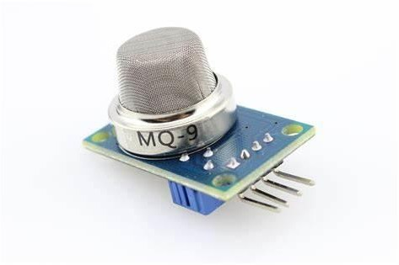

**4.2.1Gas(MQ9) Sensor**

## Node MCU:

Node MCU Node MCU is an open-source Lua based firmware and development board specially targeted for IoT based Applications. It includes firmware that runs on the ESP8266 Wi- Fi SoC from Express if Systems, and hardware which is based on the ESP-12 module.

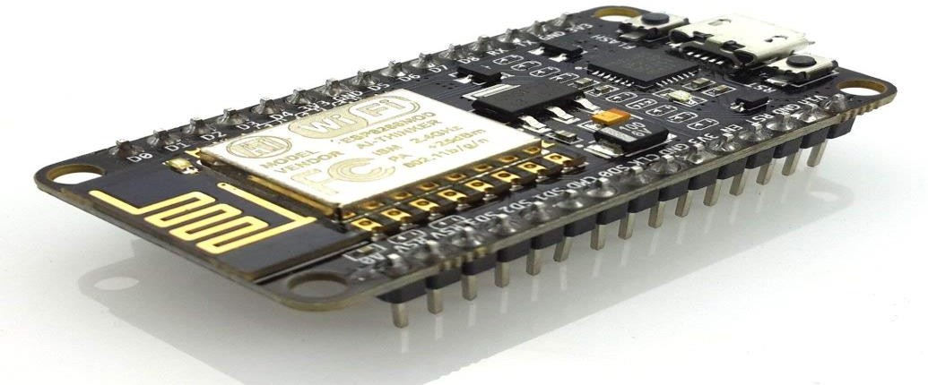

**4.2.3 Node MCU**

## Node MCU ESP8266 Specifications & Features

* + - 1. Microcontroller: Ten silica 32-bit RISC CPU xtensa LX106
      2. Operating Voltage: 3.3V
      3. Input Voltage: 7-12V
      4. Digital I/O Pins (DIO): 16
      5. Analog Input Pins (ADC)

## Features:

1. SPIs: 1
2. I2Cs: 1
3. Flash Memory: 4 MB
4. SRAM: 64 KB
5. Clock Speed: 80 MHz
6. USB-TTL based on CP2102 is included onboard, Enabling Plug
7. PCB Antenna
8. Small Sized module to fit smartly inside your IoT projects

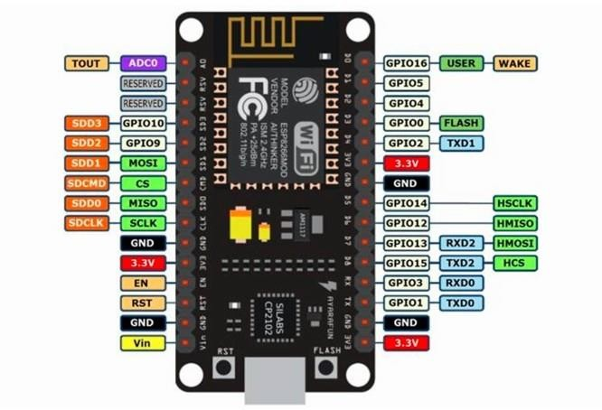

* + 1. **Pin Structure of Node MCU**

**LDR SENSOR**

LDR (Light Dependent Resistor) as the name states is a special type of resistor that works on the photo-conductivity principle means that resistance changes according to the intensity of light. Its resistance decreases with an increase in the intensity of light.

It works on the principle of photo conductivity whenever the light falls on its photo conductive material, it absorbs its energy and the electrons of that photo-conductive material in the valence band get excited and go to the conduction band and thus increasing the conductivity as per the increase in light intensity.

Also, the energy in incident light should be greater than the band-gap gap energy so that the electrons from the valence band got excited and go to the conduction band.

The LDR has the highest resistance in dark around 1012 Ohm and this resistance decreases with the increase in Light.

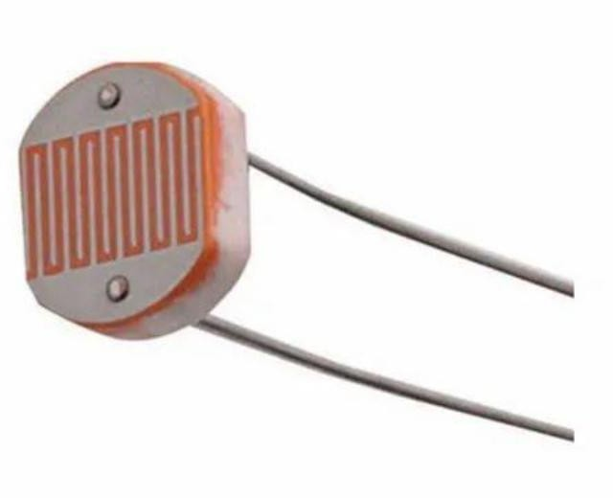

## Soil moisture sensor:

Soil Moisture Sensor is one kind of low-cost electronic sensor that is used to detect the moisture of the soil. This sensor can measure the volumetric content of water inside the soil. This sensor is consist of mainly two parts, one is Sensing Probes and another one is the Sensor Module. The probes allow the current to pass through the soil and then it gets the resistancevalue according to moisture value in soil. The Sensor Module reads data from the sensor probes and processes the data and converts it into a digital/analog output. So, the Soil Moisture Sensor can provide both types of output Digital output (DO) and Analog output (AO).

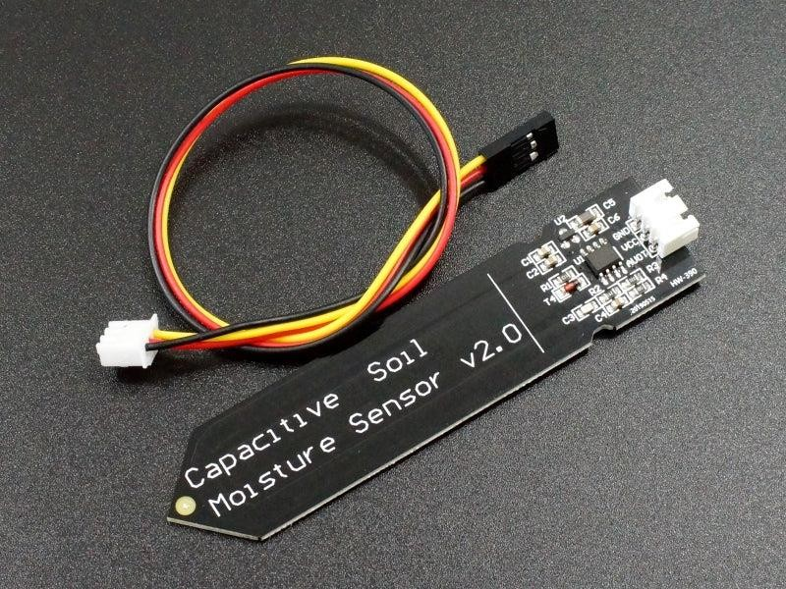

**4.2.4 Soil Moisture Sensor**

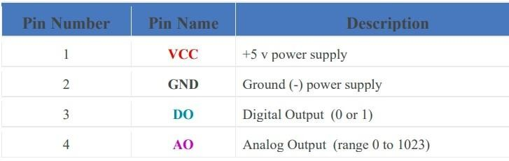

## Soil Moisture Sensor Module Hardware Overview:

This Module is consist of mainly two parts, one is Sensing Probes and another one is the Sensor Module(or) Sensing Probes

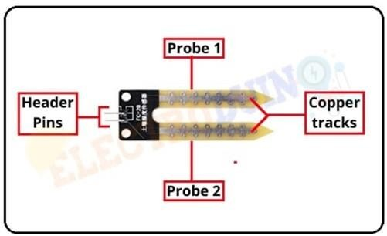

**4.2.4 Soil Moisture Sensor Module Hardware Overview**

The Sensing Probes consists of two nickel-coated copper tracks. Also, it has two Header pins, these are internally connected to the two copper tracks of the Sensing Probes. These pins areused to connect the Sensing Probes to Sensor Module through two jumper wires. Always, one pin of the sensor module provides a +5v current to the one Probe, and another pin of the sensor module has received the return current from the other Probe. Normally under dry soil conditions, it provides high resistance and less conductivity. So, the 5v current cannot be passed from one probe to another probe. Its resistance will vary according to the amount of water in the soil. When more water in the soil its resistance will decreases and conductivity will increase. So,when water increasing in the soil it can pass more current from one probe to another probe.

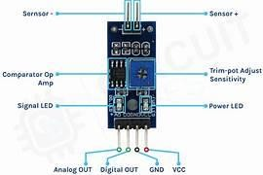

* + 1. **Sensor Module**

The key components of the Sensor module circuit are LM393 Comparators, Variable Resistor (pot), Power LED, output LED. How Soil Moisture Sensor Works At first, we need to connect the Sensing Probe to the Sensor Module circuit using the jumper wire and enter the

props into the dry soil. Now connect the sensor to the 5v power supply. Then set the threshold voltage at the Non-Inverting input (3) of the IC in dry soil condition by rotating the potentiometer knob for setting the sensor sensitivity. When more water in the soil then prob’s conductivity will increase and resistance will decrease. So, a Low amount of voltage from the sensing probe is given to the Inverting input (2) of the IC. Then the LM393 Comparator IC compares this voltage with the threshold voltage. In this condition, this input voltage is less than the threshold voltage, so the soil sensor output goes LOW (0).

When less water in the soil then prob’s have low conductivity and high resistance. So, a High amount of voltage from the sensing probe is given to the Inverting input (2) of the IC. Then the LM393 Comparator IC compares this voltage with the threshold voltage. In this condition, this input voltage is greater than the threshold voltage, so the sensor output goes High (1).

|  |  |
| --- | --- |
| **PARAMETER** | **VALUE** |
| Operating voltage | 3.3v – 5v |
| Operating Current | 15 mA |
| Comparator chip | LM393 |
| Sensitivity | Adjustable via pot |
| Output type | Analog Output voltage (AO) and Digital  switching voltage (DO) |
| LED Light indicators | Power(red/green) and Output(red/green) |
| Sensing probes | Nickel plate on one side |
| Module PCB size | 3.2cm * 1.4cm |

## DHT11 (Temperature & Humidity Sensor):

DHT11 consist of both humidity and temperature sensor. For measuring humidity there are two electrodes with moisture holding substrate between them. So when the humidity changes, the resistance between these electrodes changes and conductivity of the substrate changes. This change in resistance are measured and processed by the IC which makes it ready to be read by a microcontroller. Fig (2). DHT 11 On the other side for measuring temperature DHT11 sensor use a NTC temperature sensor or a thermistor. A thermistor changes its resistance with change of the temperature because it is variable resistor.

These sensors are made by sintering of semi-conductive materials (ceramic and polymers), which provide large changes in the resistance with just small changes in temperature. The term “NTC” means “Negative Temperature Coefficient”, which means that the resistance decreases with increase of the temperature. DHT11 Temperature & Humidity Sensor features a temperature & humidity sensor complex with a calibrated digital signal output. By using the exclusive digital- signal-acquisition technique and temperature & humidity sensing technology, it ensures high reliability and excellent long-term stability. This sensor includes a resistive-type humidity measurement component and an NTC temperature measurement components , and connects to a high performance 8-bit microcontroller, offering excellent quality, fast response, anti-interference ability and cost-effectiveness.

Each DHT11 element is strictly calibrated in the laboratory that is extremely accurate on humidity calibration. The calibration coefficients are stored as programming in the OTP memory, which are used by the sensor’s internal signal detecting process. The single-wire serial interface makes system integration quick and easy. Its small size, low power consumption and up-to- 20meter signal transmission making it the best choice for various applications, including those most demanding ones. The component is 4-pin single row pin package. It is convenient to connect and special packages can be provided according to users’ request.

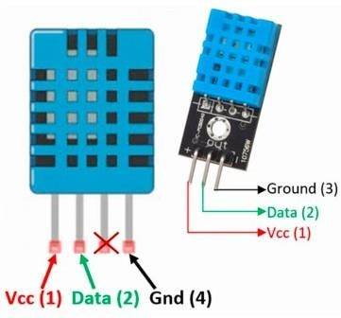

* + 1. **DHT11 Temperature and Humidity Sensor**

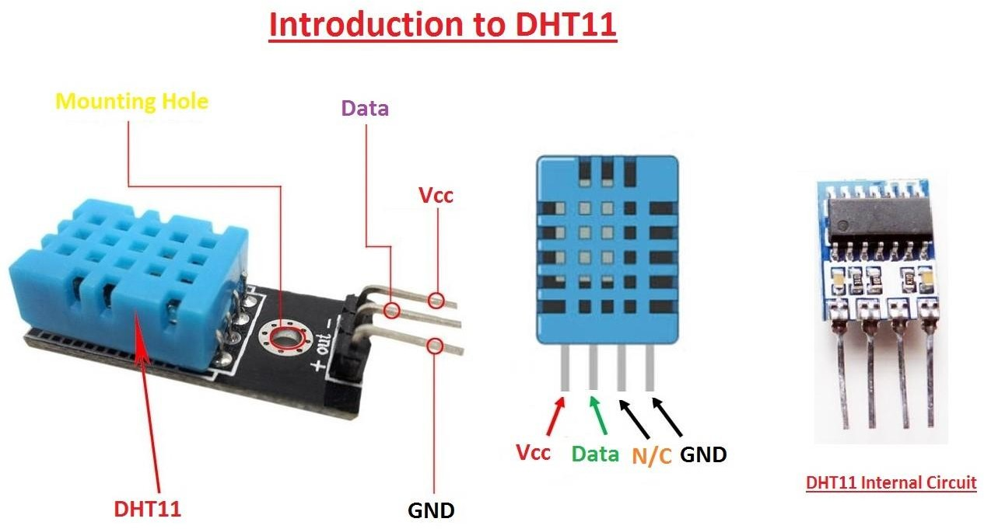

## Relay Module:

A power relay module is an electrical switch that is operated by an electromagnet. The electromagnet is activated by a separate low-power signal from a micro controller. When activated, the electromagnet pulls to either open or close an electrical circuit.

A power relay module is an electrical switch that is operated by an electromagnet. The electromagnet is activated by a separate low-power signal from a micro controller. When activated, the electromagnet pulls to either open or close an electrical circuit.

A simple relay consists of wire coil wrapped around a soft iron core, or solenoid, an iron yoke that delivers a low reluctance path for magnetic flux, a movable iron armature and one or more sets of contacts. The movable armature is hinged to the yoke and linked to one or more set of the moving contacts. Held in place by a spring, the armature leaves a gap in the magnetic circuit when the relay is de-energized. While in this position, one of the two sets of contacts is closed while the other set remains open.

When electrical current is passed through a coil, it generates a magnetic field that in turn activates the armature. This movement of the movable contacts makes or breaks a connection with the fixed contact. When the relay is de-energized, the sets of contacts that were closed, open and breaks the connection and vice versa if the contacts were open. When switching off the current to the coil, the armature is returned, by force, to its relaxed position. This force is usually provided by a spring, but gravity can also be used in certain applications. Most power relays are manufactured to operate in a quick manner.

For distribution of power in high current applications, GEP Power Products is the industry leader in high power relay module design and manufacturing.

Rated up to 70 amps, GEP’s power relay modules are designed for seamless integration in high power distribution applications. The convenient integral mounting brackets provide easy installation and accessibility. With endless options such as terminal position assurance available

for wire retention, GEP Power Products’ [power distribution solutions](https://www.geppowerproducts.com/standard-products/) and off-road industry knowledge are second to none.

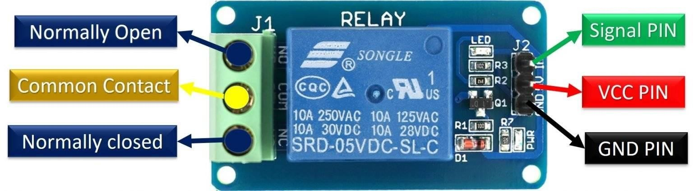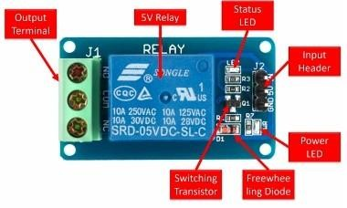

* + 1. **Relay Module**

## Water Pump:

This is a low cost mini submersible type water pump that works on 3-6V DC. It is extremely simple and easy to use. Just immerse the pump in water, connect a suitable pipe to the outlet and power the motor with 3-6V to start pumping water. Great for building science projects, fire-extinguishers, firefighting robots, fountains, waterfalls, plant watering systems etc. This motor is small, compact and light. It can be controlled from a micro controller/Arduino using our DC Motor Drivers or one of our Relay Boards. You may use our 5V SMPS Power Supply Adapter to run this pump. You may also use our 6V Solar Panel to run the pump with appropriate a 6V voltage regulator

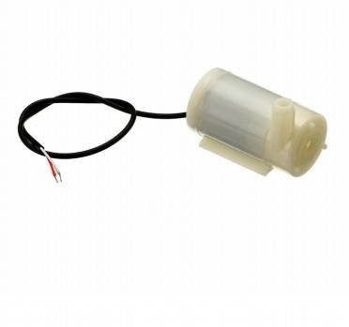

**4.2.8 Water Pump**

# CHAPTER -5

**5.1 HARDWARE MODEL OF IOT BASED SMART IRRIGATION MONITORING SYSTEM:**

The below model consists of temperature humidity sensor, rain drop sensor, light, gas(MQ9) sensor, node MCU, relay module.so these all sensors are given as inputs to the node MCU. The sensor is interface with Arduino Uno such as DHT11 Temperature, Humidity, Soil moisture and Rain, detection sensor is used. The data acquired from sensors are transmitted to the web server using wireless transmission (WIFI moduleESP8266).The data processing is the task of checking various sensors data received from the field with the already fixed

threshold values.

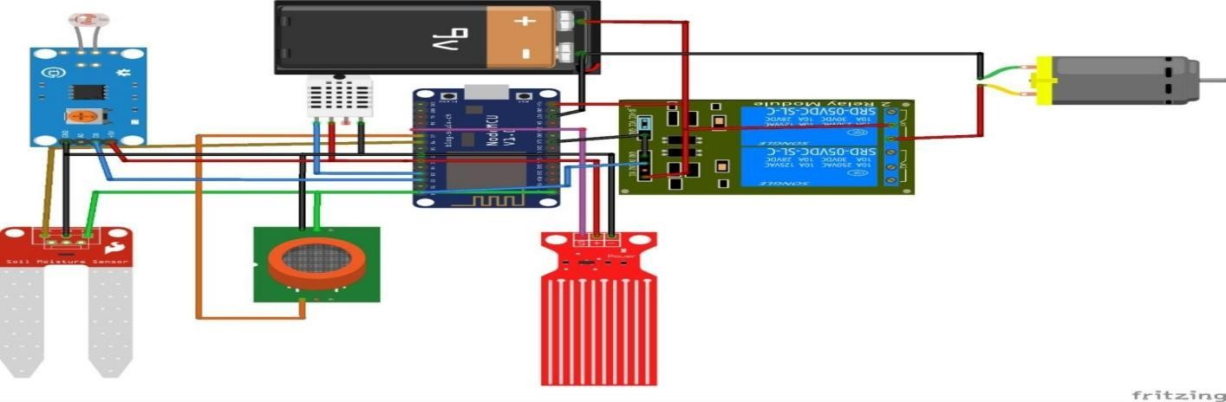

* 1. **HARDWARE MODEL OF IOT BASED SMART IRRIGATION MONITORING SYSTEM**

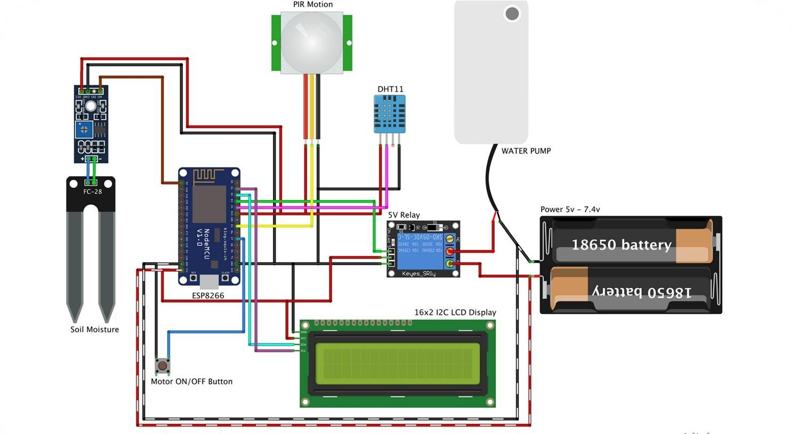The motor will be switched ON automatically if the soil moisture value falls below the threshold and vice- versa. the farmer can even switch ON the Motor from mobile using mobile application. The irrigation system automated once the control received from the web application or mobile application. relay is used to pass control form web application to the electrical switches using Arduino microcontroller. The circuits with low power signal can be controlled using relay. the web application will be designed to monitor the field and crops from anywhere using internet connection. To control the Arduino processing IDE is used, the webpage can be communicated using the processing IDE. The mobile application will be developed in android. The mobile application helps to monitor a controlled filed from anywhere.

**HARDWARE MODEL OF IOT BASED SMART IRRIGATION MONITORING SYSTEM**

* 1. **Algorithms(dumped in Aurdino):**

/* Connections Relay. D3

Btn. D7 Soil. A0 PIR. D5 SDA. D2 SCL. D1

Temp. D4 mq9 D8

*/

#include <LiquidCrystal_I2C.h> #define BLYNK_PRINT Serial #include <ESP8266WiFi.h> #include <BlynkSimpleEsp8266.h> #include <DHT.h>

//Initialize the LCD display LiquidCrystal_I2C lcd(0x27, 20, 4);

char auth[] = "egLJJ9ZAIRsaXJNvTTBim9SazrfbZkBz"; //Enter your Blynk Auth token char ssid[] = "Mi11X"; //Enter your WIFI SSID

char pass[] = "qw123457"; //Enter your WIFI Password

DHT dht(D4, DHT11);//(DHT sensor pin,sensor type) D4 DHT11 Temperature Sensor BlynkTimer timer;

//Define component pins #define led D0

#define mq D8

#define soil A0 //A0 Soil Moisture Sensor #define PIR D5 //D5 PIR Motion Sensor int PIR_ToggleValue;

void checkPhysicalButton(); int relay1State = LOW;

int pushButton1State = HIGH;

#define RELAY_PIN_1 D3 //D3 Relay #define PUSH_BUTTON_1 D7 //D7 Button #define VPIN_BUTTON_1 V12

//Create three variables for pressure double T, P;

char status;

void setup() { Serial.begin(9600); lcd.begin(); lcd.backlight(); pinMode(PIR, INPUT); pinMode(mq, INPUT);

pinMode(RELAY_PIN_1, OUTPUT);

digitalWrite(RELAY_PIN_1, LOW); pinMode(PUSH_BUTTON_1, INPUT_PULLUP);

digitalWrite(RELAY_PIN_1, relay1State); pinMode(led, OUTPUT);

pinMode(D6, OUTPUT);

Blynk.begin(auth, ssid, pass, "blynk.cloud", 80); dht.begin();

lcd.setCursor(0, 0); lcd.print(" Initializing "); for (int a = 5; a <= 10; a++) { lcd.setCursor(a, 1); lcd.print(".");

delay(500);

}

lcd.clear(); lcd.setCursor(11, 1); lcd.print("W:OFF");

//Call the function

timer.setInterval(100L, soilMoistureSensor); timer.setInterval(100L, DHT11sensor); timer.setInterval(500L, checkPhysicalButton); lcd.setCursor(0,0);

lcd.print(" RAGHU ENGINEERING");

}

//Get the DHT11 sensor values void DHT11sensor() {

float h = dht.readHumidity(); float t = dht.readTemperature();

if (isnan(h) || isnan(t)) {

Serial.println("Failed to read from DHT sensor!"); return;

}

Blynk.virtualWrite(V0, t); Blynk.virtualWrite(V1, h);

lcd.setCursor(0, 2); lcd.print("T:"); lcd.print(t);

lcd.setCursor(8, 2); lcd.print("H:"); lcd.print(h);

}

//Get the soil moisture values void soilMoistureSensor() { int value = analogRead(soil);

value = map(value, 730,290, 0, 100); Blynk.virtualWrite(V3, value); lcd.setCursor(0, 3);

lcd.print("S:"); lcd.print(value); lcd.print(" ");

}

//change

void soilMoisture() {

int value = analogRead(soil);

value = map(value,726,290, 0, 100);

}

//Get the PIR sensor values void PIRsensor() {

bool value = digitalRead(PIR); if (value) {

Blynk.logEvent("pirmotion","WARNNG! Motion Detected!"); //Enter your Event Name WidgetLED LED(V5);

LED.on();

} else {

WidgetLED LED(V5); LED.off();

}

}

BLYNK_WRITE(V6)

{

PIR_ToggleValue = param.asInt();

} BLYNK_CONNECTED() {

// Request the latest state from the server Blynk.syncVirtual(VPIN_BUTTON_1);

}

BLYNK_WRITE(VPIN_BUTTON_1) {

relay1State = param.asInt(); digitalWrite(RELAY_PIN_1, relay1State);

}

void checkPhysicalButton()

{

if (digitalRead(PUSH_BUTTON_1) == LOW) {

// pushButton1State is used to avoid sequential toggles if (pushButton1State != LOW) {

// Toggle Relay state relay1State = !relay1State;

digitalWrite(RELAY_PIN_1, relay1State);

// Update Button Widget Blynk.virtualWrite(VPIN_BUTTON_1, relay1State);

}

pushButton1State = LOW;

} else {

pushButton1State = HIGH;

}

}

void loop() {

int sv=analogRead(A0);

sv = map(sv, 730,290, 0, 100);

if (sv<40){ Blynk.logEvent("water","water plants"); WidgetLED LED(V4);

LED.on();

}

else{

WidgetLED LED(V4); LED.off();

}

int value=digitalRead(mq); if (value==0){ lcd.setCursor(0,1); lcd.print("GAS detected");

digitalWrite(D0,HIGH); digitalWrite(D6,LOW);

Blynk.logEvent("gas","Flammable gases detected"); WidgetLED LED(V13);

LED.on();

}

else{ lcd.setCursor(0,1);

lcd.print("GAS not detected "); digitalWrite(D0,LOW); digitalWrite(D6,HIGH); WidgetLED LED(V13); LED.off();

}

if (PIR_ToggleValue == 1)

{

lcd.setCursor(5, 3); lcd.print("M:ON "); PIRsensor();

}

else

{

lcd.setCursor(5, 3); lcd.print("M:OFF"); WidgetLED LED(V5); LED.off();

}

if (relay1State == HIGH)

{

lcd.setCursor(11, 3); lcd.print("W:OFF");

}

else if (relay1State == LOW)

{

lcd.setCursor(11, 3); lcd.print("W:ON ");

}

Blynk.run();//Run the Blynk library timer.run();//Run the Blynk timer

}

**BLOCK DIAGRAM**

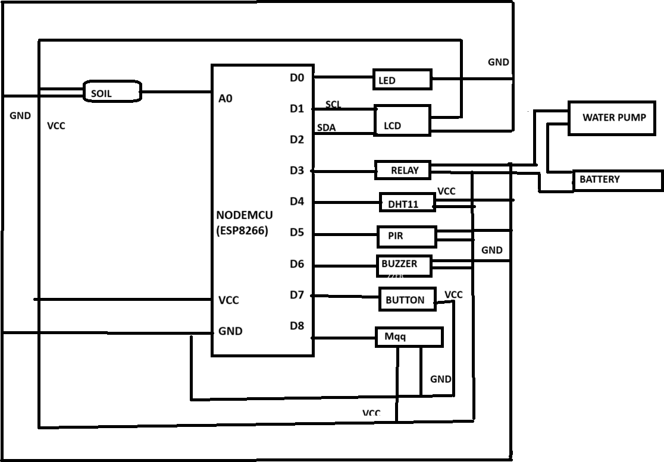

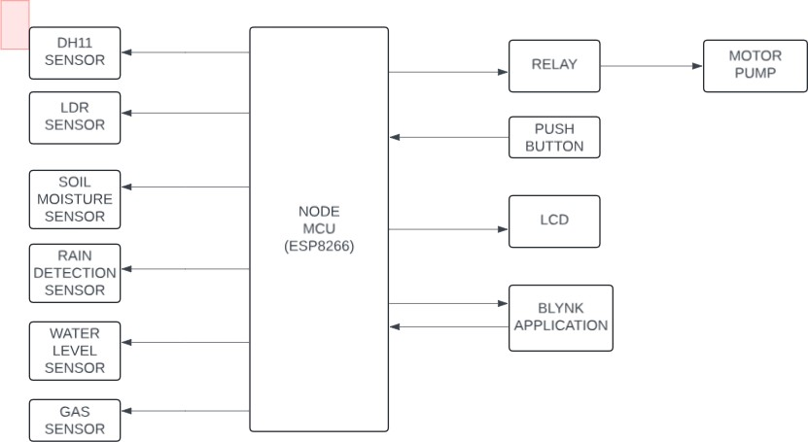

* 1. **HARDWARE MODEL REPRESENTATION OF IOT BASED SMART**

**I R R I G A T I O N MONITORING SYSTEM**

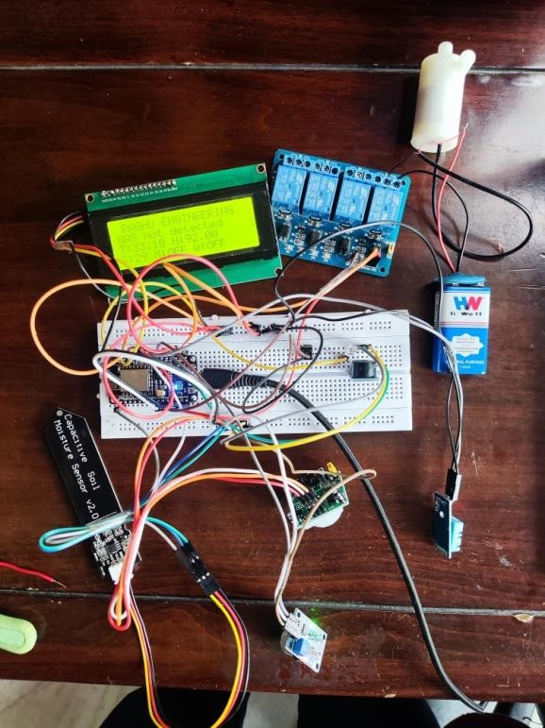 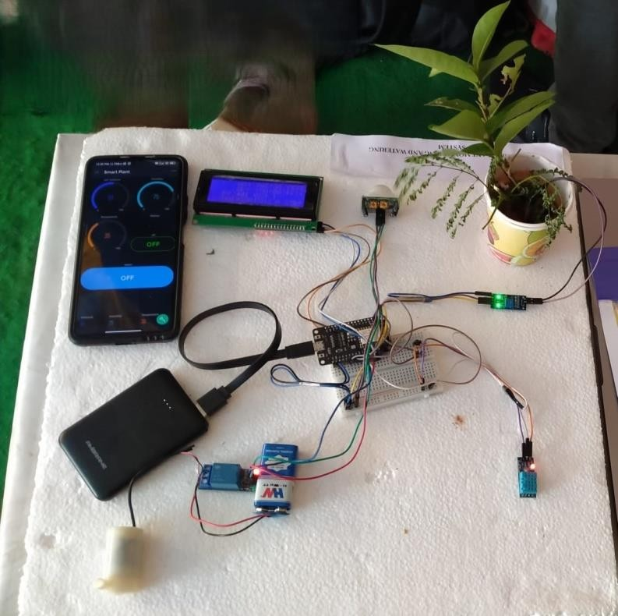

**5.3 HARDWARE MODEL REPRESENTATION OF IOT BASED SMART IRRIGATION MONITORING SYSTEM**

## Working:

* + 1. First we switch on the system Then the system operates automatically based on the atmospheric conditions.
    2. We can also switch on the system manually using the blink app in mobile.
    3. Based on the conditions i.e Temperature, Rainy Weather, Light and Gas(MQ9), The system will find the parameters and perform the given functions and also send a gmail to the user through the blink app.
    4. There will also be a blink console website which will display the dashboard of all the parameters.
    5. The above circuit diagram consists of temperature humidity sensor, rain drop sensor, light

, gas(MQ9) sensor ,node MCU ,relay module.so these all sensors are given as inputs to the node MCU

* + 1. **Sensor data acquisition :-**
    2. The sensor is interface with Arduino Uno such as DHT11 Temperature, Humidity, Soil moisture and Rain
    3. detection sensor is used.
    4. **Wireless data transmission :-**
    5. The data acquired from sensors are transmitted to the web server using wireless transmission (WIFI module

**11**. (ESP8266).

1. **Data processing and Decision making :-**
2. The data processing is the task of checking various sensors data received from the field with the already fixed
3. threshold values.
4. The motor will be switched ON automatically if the soil moisture value falls below the threshold and vice- versa.
5. The farmer can even switch ON the Motor from mobile using mobile application.
6. **Automation and irrigation system :-**
7. The irrigation system automated once the control received from the web application or mobile application. The
8. relays are used to pass control form web application to the electrical switches using Arduino microcontroller. The
9. circuits with low power signal can be controlled using relay.
10. **Web application :-**
11. The web application will be designed to monitor the field and crops from anywhere using internet connection.
12. To control the Arduino processing IDE is used, the webpage can be communicated using the processing IDE.
13. **Mobile Application :-**
14. The mobile application will be developed in android. The mobile application helps to monitor an controlled filed from anywhere.

## CHAPATER 6

**6.1 software for IOT based smart irrigation monitoring system:**

## 6.1.1 BLINK application interface:

The app connects your home to your phone in HD video so you can see and protect what matters most. With multi-system support, you can use Blink to watch your home, vacation home, or business all at the same time. Plus, you can control multiple camera systems within one single app.

## MOBILE INTERFACE

**ON STATE OFF STATE**

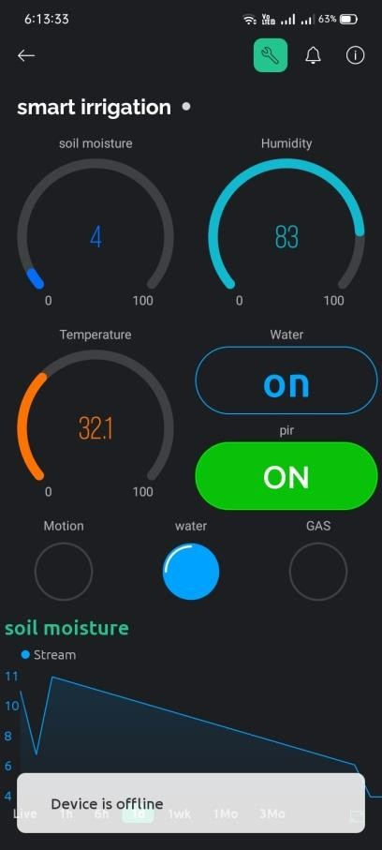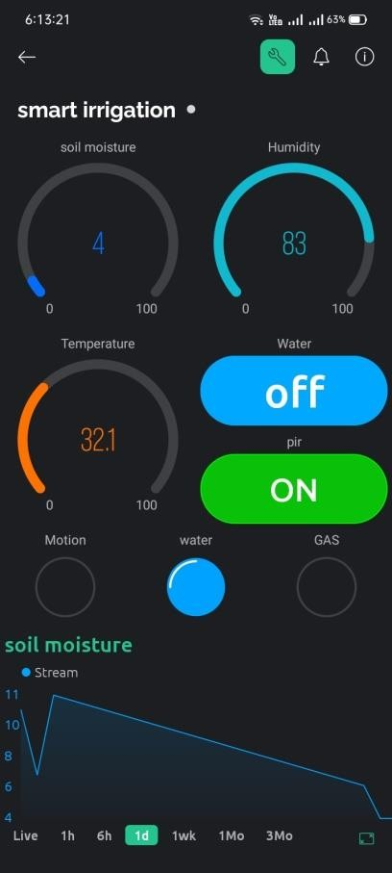

**6.1.1 BLINK application interface**

## BLINK DASHBOARD IN COMPUTER

**ON STATE**

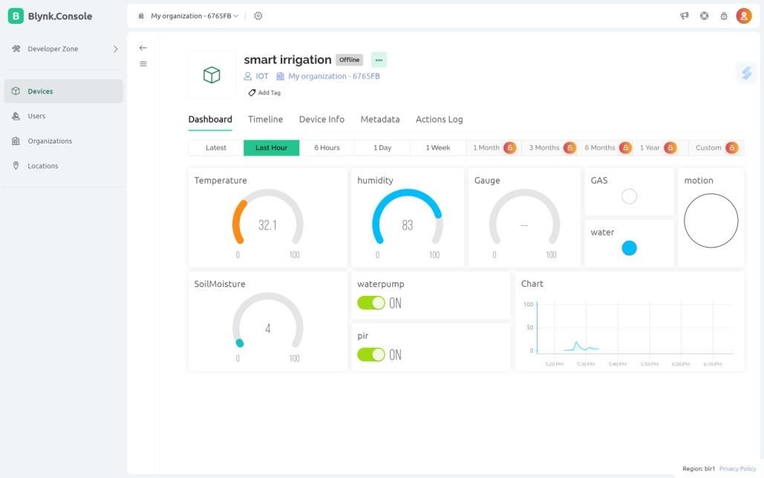

## OFF STATE

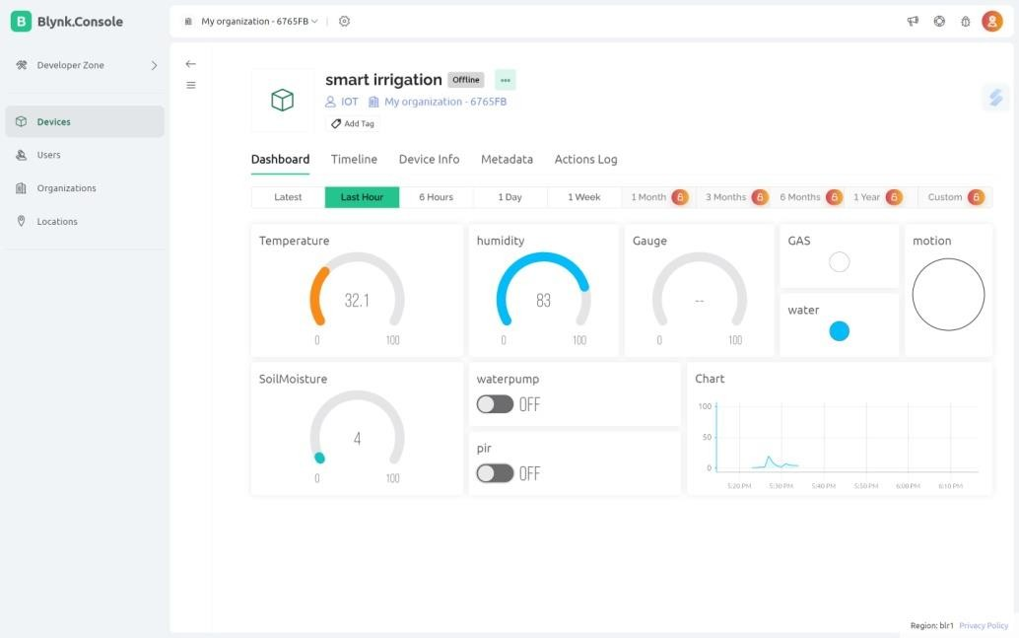

* + 1. **BLINK application interface**

## DASHBOARD interface

The dashboard interface is used to the see the graphical representation of the result.

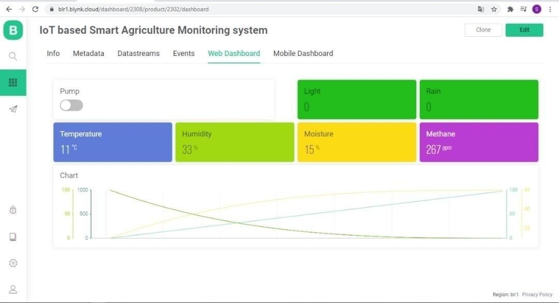

**6. 1.2 DASHBOARD interface**

* An interface can fail its users in several areas, but the data dashboard seems to carry with it aparticular risk. Maybe because it’s easy to produce a page that looks impressive through the use of fancy gauges, graphs, and charts yet still misses the mark with users. Not that there is anything wrong with making a dashboard visually appealing it’s a key part of the user experience. But I’d suggest an approach to designing dashboards that begins with

the what before getting into the specifics of how to present the display.

* “A single-screen display of the most important information needed to do a job, designed forrapid monitoring.”
* More specifically, the mission of a dashboard should be to
  + Provide an overview of what’s going on
  + Highlight what needs attention
  + Provide easily discoverable ways to drill down into details as necessary
* A dashboard is often designed as the initial view when logging into a system.

# CHAPTER 7 CONCLUSION:

Agricultural monitoring is needed to reduce the need for human intervention in farming. This demonstrates the advantage of building the rules with mathematical equations and linguistic variables. This process is aimed to educate the farmer on the use of an integrated technology system to monitor and control operations. The system can also create an excellent set of decision-makers with reduced manual contribution. Furthermore,the outcomes help us to understand more about the significance of each variable to obtain healthy plants. This achievement leads to a smart water management. After all, none of the previous studies investigated the chili plant. Chili plants grown in containers have specific needs and can perform exceptionally well given the right conditions. For example, the seeds need more warmth to germinate, and the plants benefit from drier soil in-between watering. However, there are still a few issues that need to be addressed. The second issue is maintaining the connectivity with the final output, whereby the application layer involves the IoT and provides management information to farmers. For future enhancement, we would like to attain more data so that we can run training and testing of the data. We will also validate the data with different subset. for better results we have used gas(MQ9) sensor and raindrop sensors and we got desired output in thesystem

## Future scope:

In this Project we are going to deal with basic and important concepts of IOT and its scopein upcoming future. This Practical Studies explains the need of IOT in day to day life for different applications and gives brief information about IOT. increases productivity, reduces manual work, reduces time and makes farming efficient. By using IoT crop monitoring can be easily done to observe the growth of the crop. Soil management such as pH level and Moisture content etc can be identified easily so that farmers can sow seeds according to the soil level.

## 5.3 References:

1. Towards smart agriculture monitoring system usig fuzzy systems Noramalina Abdullah1 , Member IEEE, Noor Aerina Durani2 , Mohamad Farid Shari3 , Siong King Soon4 , Vicky Kong Wei Hau5 , Wong Ngei Siong6 and Khairul Azman Ahmad7 1-6 School of Electric and Electronic Engineering, Universiti Sains Malaysia, Engineering Campus, 14300 Penang, Malaysia 7 Faculty of Electrical Engineering, Universiti Teknologi MARA, Oermatang Pauh, Penang, Malaysia
2. Kirtan Jha et al., “A Comprehensive Review on Automation in Agriculture using Artificial Intelligence”, Artificial Intelligence in Agriculture, pp. 1–12, February, 2019.
3. Veronica and Francisco, “From Smart Farming towards Agriculture 5.0: A Review on Crop Data Management”, Agronomy, pp 1-21, February 2020.
4. Imran Ali et al, “Monitoring and Control Systems in Agriculture Using Intelligent Sensor Techniques: A Review of the Aeroponic System”, Journal of Sensors (Hindawi), 18 pages, December 2018.
5. Tilva et al., “Weather Based Plant Diseases Forecasting Using Fuzzy Logic”, Nirma University International Conference on Engineering (NUiCONE), 1–5 October, 2013.
6. Gupta et al., “Need of Smart Water Systems in India”, International Journal of Engineering Research, 11 (4), 2216–2223, 2016.
7. Towards Smart Agriculture Monitoring Using Fuzzy Systems Noramalina Abdullah1, Member IEEE, Noor Aerina Durani2, Mohamad Farid Shari3, Siong King Soon4, Vicky Kong Wei Hau5, Wong Ngei Siong6 and Khairul Azman Ahmad7.
8. Mustafa et al. “Agricultural Produce Sorting and Grading Using Support Vector Machines and Fuzzy Logic”, IEEE International Conference on Signal and Image Processing Applications, 391–396, 2009.
9. Philomine Roseline et al., “Design and Development of Fuzzy Expert System for Integrated Disease Management in Finger Millets”, International Journal of Computer Applications 56(1):31-36, October 2012.
10. Heidi Webber et al., “Uncertainity in Future Irrigation Water Demand and Risk of Crop Failure” Environment Research Letter, 11 074007, 2016.
11. E. Neamatollahi et al., ““Agricultural Optimal Cropping Pattern Determination Based on Fuzzy System”, Fuzzy Information Engineering, 9: 479-491, 2017.
12. Si et al, “Design of Control System of Laser Levelling Machine Based on Fuzzy Control Theory”, International Conference on Computer and Computing Technologies in Agriculture, pp. 1121–1127, 2007.
13. Sannakki et al. “Leaf Disease Grading by Machine Vision and Fuzzy Logic”, International Journal of Computer Technology Application, 2 (5), 1709–1716, 2011.
14. Valdés-Vela et al., “Soft Computing Applied to Stem Water Potential Estimation: A Fuzzy Rule Based Approach”, Computer Electronic Agriculture. 115, pp.150–160, 2015.
15. Denge et al. “A Review of Multi Criteria Decision Making (MCDM) Towards Sustainable Renewable Energy Development”, Renewable & Sustainable Energy Review, 69, 596–609, 2017.
16. Giusti and Marsili Libellia , “A Fuzzy Decision Support System for Irrigation and Water Conservation in Agriculture”, Environment Modelling Software, 63, 73–86, 2015.
17. Yang et al. “Development of an Image Processing System and a Fuzzy Algorithm for Site- Specific Herbicide Applications,” Precision Agriculture, vol. 4, no. 1, pp. 5–18,2003.
18. et al. “Irrigation Decision Making System Based on the Fuzzy Control Theory and Virtual Instrument,” Transactions of the Chinese Society of Agricultural Engineering, vol. 23, no. 8, pp. 165–169, 2007.
19. Varun Khatri, “Application of Fuzzy Logic in Water Irrigation System”, International Research Journal of Engineering and Technology (IRJET), Page 3372, 5(04),2018.
20. S Mamatha and Soya, “Implementation of Fuzzy Logic in Estimating Yield of a Vegetable Crop”, Journal of Physics, January 2020.
21. T. Asao, “Hydroponics - A Standard Methodology for Plant Biological Researche”, Intech, 2012.
22. A. Barr et al., “Combination of Multi-agent Systems and Wireless Sensor Networks for the Monitoring of Cattle,” Sensors, vol. 18, no. 2, p. 108, 2018.
23. B. Basnet and J. Bang, “The State-of-the-art of Knowledge Intensive Agriculture: a Review on Applied Sensing Systems and Data Analytics,” Journal of Sensors, vol. 2018, 13 pages, 2018.
24. Muhammad Osama Akbar et. al, IoT for Development of Smart Dairy Farming Journal of Food Quality, Volume 2020, <https://doi.org/10.1155/2020/4242805>

# CHAPTER *8:*

**PAPER PUBLICATION**



ISSN 2347–3657

Volume 12, Issue 2, April 2024

# IOT BASED SMART IRRIGATION MONITORING SYSTEM

R Raakesh Kumar1, Sri Harsha Digvijay Mullapudi2, Lagudu Mayuri3, Rajana Prakash4, Majji Chandra Mouli5

1 Assistant Professor, Department of Computer Science and Engineering, Raghu Engineering College (A), Dakamarri, Bheemunipatnam, Visakhapatnam Dist, Andhra Pradesh

2,3,4,5 Department of Computer Science and Engineering, Raghu Engineering College (A), Dakamarri, Bheemunipatnam, Visakhapatnam Dist, Andhra Pradesh

# ABSTRACT

The internet of things (IOT) describes the network of physical objects that are embedded with sensors, software, and other technologies for the purpose of connecting data with other devices and systems over the internet. Agriculture is the one of the most dominant sectors that nothing can match its importance and the work of it. We here implemented our thoughts and worked on Modern Agriculture technology which is an IOT based agriculture monitoring system. Compared to the previous results, here LDR module along with fuzzy logic are used as it helps in using the parameter of light, In this project the intelligence of the proposed system is based on a smart algorithm, which considers sensed data along with the parameters like air, temperature, humidity, moisture. The complete system where the sensor node data is wirelessly collected over the cloud using web- services and a web-based information visualization and decision support system provides the real- time information insights based on the analysis of sensors data and weather forecast data, if the sensed value goes beyond the threshold values set in the program, the water pump will be automatically switched on/off .We will provide basic Software Prototype and Hardware Model for data visualization. Conventional farming is labor-consuming and the need to continuously monitor crops can be a burden for farmers. By realizing the concept of smart farming based on Internet of Things (IoT) technology, farmers can use a mobile application to observe and monitor air humidity, air temperature, and soil moisture – factors that can affect plant growth. Furthermore, the use of timers to control the pumps in conventional watering systems is not always practical in real-life cases. This paper proposes a framework that enables advanced fuzzy logic to control a pump’s switching time according to user-defined variables, whereby sensors are the main aspect of and contributor to the system. Our proposed idea offers great potential for excellent performance as an interface between the sensors as the input and the IoT as the output medium. A comparison is made between the proposed system and manual handling. The results prove that the water consumption and watering time has been reduced significantly.

**Keywords** : Agriculture, Fuzzy Logic, Prototype, Smart Farming, Visualization

ISSN 2347–3657

Volume 12, Issue 2, April 2024

# I Introduction

The Internet of Things, or IoT, refers to the billions of physical devices around the world that are now connected to the internet, all collecting and sharing data[1-5]. Thanks to the arrival of super- cheap computer chips and the ubiquity of wireless networks, it's possible to turn anything, from something as small as a pill to something as big as an airplane, into a part of the IoT[6,7]. Connecting these different objects and adding sensors to them adds a level of digital intelligence to devices that would be otherwise dumb, enabling them to communicate real time data without involving a human being[8-11]. The Internet of Things is making the fabric of the world around us more smarter and more responsive, merging the digital and physical universes[12].The Internet of Things (IoT) is the network of physical objects or "things" embedded with electronics, software, sensors, and network connectivity, which enables these objects to collect and exchange data[13].

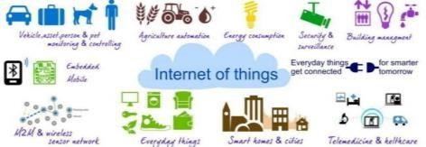

Figure 1: Internet of things

# History of IOT

* + 1. The concept of a network of smart devices was introduced in 1982, with a modified coke machine that became the first internet connected appliance [14,15].
    2. Between 1982 to 1999 many companies were working on IOT. But in 1999 IOT was introduced by British technology pioneer Kevin Ashton who coined the term in his work at Procter and gamble. But the term IOT did not step up till 2011 later in 2014 it reached mass market[16].
    3. IOT allows the objects that will connect through the internet with RFID (Radio Frequency Identification) communication methods that include wireless technology and sensors which can identify themselves uniquely[14].

# Structure of IOT

ISSN 2347–3657

Volume 12, Issue 2, April 2024

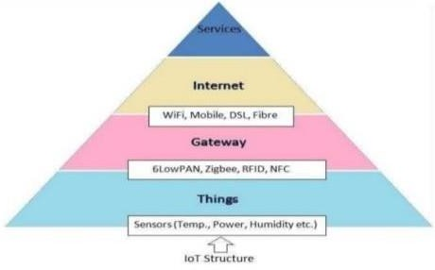

Figure 2 : Structure of IOT

IoT system architecture is often described as a **four-stage process** in which data flows from sensors attached to “things” through a network and eventually on to a corporate data center or the cloud for processing, analysis and storage[13]. In the Internet of Things, a “thing” could be a machine, a building or even a person[16]. Processes in the IoT architecture also send data in the other direction in the form of instructions or commands that tell an actuator or other physically connected device to take some action to control a physical process[3]. An actuator could do something as simple as turning on a light or as consequential as shutting down an assembly line if impending failure is detected[1].

# Literature Review

* 1. **IoT-Based Smart Irrigation System for Agriculture**

This paper discusses the design and implementation of a smart irrigation system using IoT technology. The system employs sensors to monitor soil moisture, temperature, and humidity, allowing for precise irrigation control. Results show improved water efficiency and crop yield[17].

# Wireless Sensor Networks for Precision Agriculture: A Review

This review paper provides an overview of wireless sensor networks (WSNs) in precision agriculture, including smart irrigation systems. It covers various sensor types, communication protocols, and applications. The authors discuss the potential benefits of IoT-based irrigation systems in optimizing water usage and enhancing agricultural productivity[18].

# IoT-Based Smart Irrigation Systems: A Review of Literature

This review paper examines existing literature on IoT-based smart irrigation systems. It analyzes the design, implementation, and performance of different systems, highlighting their effectiveness in conserving water and improving crop yield. The paper also identifies challenges and future research directions in this field[19-21].

ISSN 2347–3657

Volume 12, Issue 2, April 2024

# A Survey on IoT Applications in Agriculture

This survey paper explores the use of IoT technology in agriculture, with a focus on smart irrigation systems. It discusses the integration of sensors, actuators, and communication networks to create intelligent irrigation solutions. The authors review various IoT-based approaches and their impact on water management and agricultural sustainability[22].

# Smart Irrigation Management Using IoT

This paper presents a case study of a smart irrigation management system based on IoT technology. It describes the deployment of sensors in agricultural fields to monitor soil moisture levels and weather conditions in real-time. The system utilizes data analytics to optimize irrigation scheduling, resulting in water savings and improved crop health[23].

# Methodology

The below block diagram consists of temperature humidity sensor, rain drop sensor, light, gas(MQ9) sensor, node MCU, relay module.so these all sensors are given as inputs to the node MCU. The sensor interfaces with Arduino Uno such as DHT11 Temperature, Humidity, Soil moisture and Rain detection sensor. The data acquired from sensors are transmitted to the web server using wireless transmission (WIFI moduleESP8266).The data processing is the task of checking various sensor data received from the field with the already fixed threshold values.

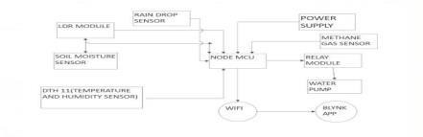

Figure 3: BLOCK DIAGRAM OF IOT BASED SMART IRRIGATION MONITORING SYSTEM

The above diagram represents temperature, humidity sensor,rain drop sensor,light,gas(MQ9) sensor,node mcu, relay module.so these all sensors are given as inputs to the node mcu The detailed proposed method works on below hardware successive components.

Rain Drop Sensor , Gas(MQ9) Gas Sensor , Node MCU , Soil Moisture Sensor , Temperature Humidity Sensor , LDR Module , Relay Module , Water Pump

# Results and Discussions

78

ISSN 2347–3657

Volume 12, Issue 2, April 2024

1. The app connects your home to your phone in HD video so you can see and protect what matters most. With multi-system support, you can use Blink to watch your home, vacation home, or business all at the same time. Plus, you can control multiple camera systems within one single app.
2. An interface can fail its users in several areas, but the data dashboard seems to carry with it a particular risk. Maybe because it’s easy to produce a page that looks impressive through the use of fancy gauges, graphs, and charts yet still misses the mark with users. Not that there's anything wrong with making a dashboard visually appealing; it's a key part of the user experience. But I’d suggest an approach to designing dashboards that begins with the what before getting into the specifics of how to present the display.
3. “A single-screen display of the most important information needed to do a job, designed for rapid monitoring.”
4. More specifically, the mission of a dashboard should be to provide an overview of what’s going on and highlight what needs attention . Provide easily discoverable ways to drill down into details as necessary
5. A dashboard is often designed as the initial view when logging into a system.

# Conclusion

Agricultural monitoring is needed to reduce the need for human intervention in farming. This demonstrates the advantage of building the rules with mathematical equations and linguistic variables. This process is aimed to educate the farmer on the use of an integrated technology system to monitor and control operations. The system can also create an excellent set of decision-makers with reduced manual contribution. Furthermore, the outcomes help us to understand more about the significance of each variable to obtain healthy plants. This achievement leads to smart water management. After all, none of the previous studies investigated the chili plant. Chili plants grown in containers have specific needs and can perform exceptionally well given the right conditions. For example, the seeds need more warmth to germinate, and the plants benefit from drier soil in-between watering. However, there are still a few issues that need to be addressed. The second issue is maintaining the connectivity with the final output, whereby the application layer involves the IoT and provides management information to farmers. For future enhancement, we would like to attain more data so that we can run training and testing of the data. We will also validate the data with different subset. for better results we have used gas(MQ9) sensor and raindrop sensors and we got desired output in the system

# References

[1]. Atzori, L., Iera, A., & Morabito, G. (2010). The internet of things: A survey. Computer Networks, 54(15), 2787-2805.

[2]. Gubbi, J., Buyya, R., Marusic, S., & Palaniswami, M. (2013). Internet of Things (IoT): A vision, architectural elements, and future directions. Future Generation Computer Systems, 29(7),

1645-1660.

ISSN 2347–3657

Volume 12, Issue 2, April 2024

[3]. Al-Fuqaha, A., Guizani, M., Mohammadi, M., Aledhari, M., & Ayyash, M. (2015). Internet of things: A survey on enabling technologies, protocols, and applications. IEEE Communications Surveys & Tutorials, 17(4), 2347-2376.

[4]. Zanella, A., Bui, N., Castellani, A., Vangelista, L., & Zorzi, M. (2014). Internet of things for smart cities. IEEE Internet of Things Journal, 1(1), 22-32.

[5]. Perera, C., Zaslavsky, A., Christen, P., & Georgakopoulos, D. (2014). Context-aware computing for the Internet of Things: A survey. IEEE Communications Surveys & Tutorials, 16(1), 414-454.

[6]. Ashton, K. (2009). That 'Internet of Things' Thing. RFID Journal, 22(7), 97-114.

[7]. Lee, I., & Lee, K. (2015). The Internet of Things (IoT): Applications, investments, and challenges for enterprises. Business Horizons, 58(4), 431-440.

[8]. Haller, S., Karnouskos, S., & Schroth, C. (2009). The internet of things in an enterprise context. In the Internet of Things (pp. 14-28). Springer, Berlin, Heidelberg.

[9]. Kranenburg, R. V., & Bassi, A. (Eds.). (2008). The internet of things: A critique of ambient technology and the all-seeing network of RFID. Institute of Network Cultures.

[10]. Miorandi, D., Sicari, S., De Pellegrini, F., & Chlamtac, I. (2012). Internet of things: Vision, applications and research challenges. Ad Hoc Networks, 10(7), 1497-1516.

[11]. Perera, C., Zaslavsky, A., Christen, P., & Georgakopoulos, D. (2014). Sensing as a service model for smart cities supported by the Internet of Things. Transactions on Emerging Telecommunications Technologies, 25(1), 81-93.

[12]. Weiser, M. (1991). The computer for the 21st century. Scientific American, 265(3), 94-104. [13]. Vermesan, O., Friess, P., & Guillemin, P. (Eds.). (2013). Internet of Things: Converging Technologies for Smart Environments and Integrated Ecosystems (Vol. 2). River Publishers. [14]. Want, R. (2006). Enabling ubiquitous sensing with RFID. Computer, 37(4), 84-86.

[15]. Sterling, B. (2005). Shaping Things. MIT Press.

[16]. Evans, D. (2011). The internet of things: How the next evolution of the internet is changing everything. Cisco Internet Business Solutions Group (IBSG).

80

ISSN 2347–3657

Volume 12, Issue 2, April 2024

[17].Gupta, P., Rani, P., Kumar, R., & Singh, P. (2020). IoT Based Smart Irrigation System for Agriculture. In 2020 2nd International Conference on Power, Energy and Environment: Towards Smart Technology (PEE), 1-4.

[18].Sharif, S., Ammad-Uddin, M., Nazir, S., & Khan, M. I. (2018). Wireless Sensor Networks for Precision Agriculture: A Review. IEEE Access, 6, 77418-77434.

[19].Pratap, A., & Yadav, R. (2020). IoT Based Smart Irrigation System for Agriculture. In 2020 International Conference on Computer, Information, and Telecommunication Systems (CITS), 1-5. [20].Dutta, S., & Roy, S. (2020). IoT Based Smart Irrigation System for Agriculture. In 2020 International Conference on Electrical, Computer and Communication Engineering (ECCE), 1-4. [21].Bhandari, A., Ghosh, A., & Thakkar, F. (2019). IoT Based Smart Irrigation System for Agriculture. In 2019 IEEE 9th International Conference on Advanced Computing (IACC), 250-254. [22]. D. Kumar, M. Vatsa, and S. N. Singh, "IoT Applications in Agriculture: A Review," in Proceedings of the 2017 7th International Conference on Cloud Computing, Data Science & Engineering-Confluence, pp. 280-285, Noida, 2017.

[23].Singh, S., & Verma, P. (2019). Smart Irrigation Management Using IoT. In 2019 International Conference on Computing, Communication, and Intelligent Systems (ICCIS), 357-361.

81

# CERTIFICATE

82

ISSN 2347–3657

Volume 12, Issue 2, April 2024

ISSN 2347–3657

Volume 12, Issue 2, April 2024